University of Houston

SQL Reports and Loaded Data Assignment

Final Path Consulting

John-Joshua Izuegbu

Adekunle Kukoyi

Chantera Lazard

Sean Tran

Pratik Asarpota

Sem Quintanilla

Faryal Khan

CIS 3365

Professor Xuqing Wu

22 October 2020

**Table of Contents**

*Klaus Creation Scripts ……………………………………………………………………………* ***2***

*Klaus Insert Scripts ……………………………………………….…………………………………….* ***14***

*Klaus Alter Scripts ………………………………………….……………………………………………****19***

*Klaus Update Scripts …………………………………………………………………………………...* ***26***

*Klaus Deletion Triggers …………………………………………………………………………………* ***30***

*SQL Reports ………………………………………………………………………………………………* ***35***

**Klaus Creation Scripts**

CREATE DATABASE Klaus_Brewing;

--Create Tables for Database--

-----------------Faryal-----------------

CREATE TABLE Employee (

Employee_Id int not null,

DepartmentId varchar(33 )not null,

Employee_Title varchar(33) not null ,

From_Date Date not null,

To_Date Date ,

isAdmin varchar(10),

[IsDeleted] bit NOT NULL DEFAULT 0

);

GO

CREATE TABLE Department (

DepartmentId varchar(33 )not null,

Employee_Id int not null,

Department_Name varchar(255 )not null,

Department_Description varchar(255),

[IsDeleted] bit NOT NULL DEFAULT 0,

);

GO

CREATE TABLE Hats (

Hat_ID int not null,

Merchandise_Type_ID int not null,

Hat_ColorID int not null ,

Hat_price float not null,

[IsDeleted] bit NOT NULL DEFAULT 0

);

GO

CREATE TABLE EmployeeInformation (

Employee_Information_Id varchar(20) not null,

Employee_Id int not null,

First_name varchar(25),

Middle_Initial varchar (25),

Last_name varchar(20),

Last_4_of_SSN INT,

DOB DATE,

isActive varchar(4),

Employee_Address NVARCHAR(100),

City varchar(20),

State varchar(20),

Zip_Code int,

Country_ID int,

[IsDeleted] bit NOT NULL DEFAULT 0

);

GO

CREATE TABLE Hat_Color (

Hat_ColorID int not null,

Color varchar(25) not null,

Hat_Description varchar(25) not null,

[IsDeleted] bit NOT NULL DEFAULT 0

);

GO

CREATE TABLE Employee_Location(

Employee_Location_ID varchar(200)not null,

Employee_Id int not null,

Brewery_ID int not null,

[isDeleted] bit not null default 0

);

GO

CREATE TABLE [Tshirt_Design](

Tshirt_Design_ID VARCHAR(15) NOT NULL,

Tshirt_Type_ID VARCHAR(10) NOT NULL,

Tshirt_Design_Name INT NOT NULL,

Tshirt_Classification VARCHAR(20) NOT NULL,

PRIMARY KEY (Tshirt_Design_ID)

);

GO

CREATE TABLE [Tshirt_Desgin](

Tshirt_Type_ID VARCHAR(20) NOT NULL,

Tshirt_Design_Name VARCHAR(20) NOT NULL,

Tshirt_Classification BIT NOT NULL,

PRIMARY KEY (Tshirt_Type_ID)

);

GO

CREATE TABLE [Tshirt_Color](

Tshirt_Color_ID INT NOT NULL,

Tshirt_Design_ID INT NOT NULL,

Tshirt_Color VARCHAR(10) NOT NULL,

PRIMARY KEY (Tshirt_Color_ID )

);

Go

CREATE TABLE [tshirt](

shirtID INT NOT NULL,

order_num INT NOT NULL,

designID INT NOT NULL,

shirtPrice INT NOT NULL,

PRIMARY KEY (shirtID)

);

Go

-----------------John-----------------

CREATE TABLE City

(

City_ID Int Not Null,

City_Name VarChar(25) Not Null,

State_ID Int Not Null,

Country_ID Int Not Null,

);

Go

CREATE TABLE State

(

State_ID Int Not Null,

State_Name VarChar(25) Not Null,

Country_ID Int Not Null,

);

Go

CREATE TABLE Country

(

Country_ID Int Not Null,

Country_Name VarChar(25) Not Null,

Zip_Code_ID Int Not Null,

);

Go

CREATE TABLE Zip_Code

(

Zip_Code_ID Int Not Null,

Zip_Code_# Int Not Null,

City_ID Int Not Null,

Country_ID Int Not Null,

);

Go

CREATE TABLE Address

(

Address_ID Int Not Null,

Address_Street VarChar(25) Not Null,

Address_Street_2 VarChar(25) Not Null,

);

Go

CREATE TABLE Address_W_Zip_Code

(

Address_ID Int Not Null,

Address_Street VarChar(25) Not Null,

Address_Street_2 VarChar(25) Not Null,

);

Go

CREATE TABLE Address_W_O_Zip_Code

(

Address_ID Int Not Null,

Address_Street VarChar(25) Not Null,

Address_Street_2 VarChar(25) Not Null,

);

Go

Create Table Klaus_Brewing_Location

(

Brewery_ID Int Not Null,

Brewery_Address VarChar(25) Not Null,

City_Id Int Not Null,

State_ID Int Not Null,

Zip_Code_ID Int Not Null,

Country_ID Int Not Null,

);

Go

CREATE TABLE [Customer_Profile] (

CustomerProfile_ID int IDENTITY(1,1) NOT NULL,

Total_Orders int,

Amount_Spent money,

Average_Amount money,

Last_Visit date,

Total_Available_Points int,

Lifetime_Points int,

Redeemed_Points int,

Lifetime_Redemptions int,

Last_Redemption int,

Available_Rewards int

);

Go

-----------------Sean-----------------

CREATE TABLE [Food_Truck_Sales] (

FoodTruck_Date date NOT NULL,

Brewery_ID int NOT NULL,

FoodTruck_Sales smallmoney NOT NULL,

Is_Deleted bit NOT NULL DEFAULT 0

);

Go

CREATE TABLE [Redemption_History] (

Redemption_ID int IDENTITY(1,1) NOT NULL,

CustomerProfile_ID int NOT NULL,

Reward_ID int NOT NULL,

Points_Value int NOT NULL

);

Go

--Sean Table Rewards--

CREATE TABLE [Rewards] (

Reward_ID int IDENTITY (1,1) NOT NULL,

Reward_Description varchar(256) NOT NULL,

Redemption_Cost int NOT NULL,

Is_Deleted bit NOT NULL DEFAULT 0

);

-----------------Adekunle-----------------

CREATE TABLE Beer(

Beer_ID int primary key identity(1,1),

Product_ID int,

Beer_Name varchar(60),

BeerType_ID int,

BeerContainerSize_ID int

)

Go

CREATE TABLE BeerType(

BeerType_ID int primary key identity(20,1),

Beer_Type varchar(60)

)

Go

CREATE TABLE Beer_Container_Size(

BeerContainerSize_ID int primary key identity(1,1),

Container_Name varchar(30),

Size varchar(30),

)

Go

CREATE TABLE BeerList(

Beer_Name varchar(60),

ABV decimal(5,1),

constraint ck_BeerList_ABV check (ABV >0 and ABV<=100),

IBU int

primary key(Beer_Name)

)

Go

CREATE TABLE Merchandise(

Merch_ID int primary key identity(2000,1),

Product_ID int,

MerchandiseType_ID int

)

Go

CREATE TABLE MerchandiseType(

MerchandiseType_ID int primary key identity(1,1),

Merchandise_Type varchar(50)

)

Go

CREATE TABLE Glassware(

Glassware_ID int primary key identity(1,1),

MerchandiseType_ID int,

GlasswareSize_ID int,

Glassware_Description varchar(60)

)

Go

CREATE TABLE GlasswareSize(

GlasswareSize_ID int primary key identity(1,1),

Size varchar(50)

)

Go

-----------------Chantera-----------------

--Table:Products--

DROP TABLE IF EXISTS [Products]

CREATE TABLE [Products] (

[Product_ID] int NOT NULL,

[Brewery_ID] int NOT NULL,

[Product_Description] varchar(256),

[Product_Price] smallmoney,

[Is_Deleted] bit

);

Go

--Misc_Item--

DROP TABLE IF EXISTS [Misc_Item]

CREATE TABLE [Misc_Item] (

[MiscItem_ID] int IDENTITY(1,1) NOT NULL,

[Product_ID] int NOT NULL,

[ItemType_ID] int NOT NULL,

[Item_Name] varchar(128)

);

Go

--Item_Type--

DROP TABLE IF EXISTS [Item_Type]

CREATE TABLE [Item_Type] (

[ItemType_ID] int IDENTITY(1,1) NOT NULL,

[Item_Type] varchar(128) NOT NULL

);

Go

--Table Coupon--

DROP TABLE IF EXISTS [Coupon]

CREATE TABLE [Coupon] (

[Coupon_Code] varchar(50) NOT NULL,

[Coupon_Value] float NOT NULL,

[Coupon_Unit] varchar(50) NOT NULL,

[Groupon] bit,

[Issue_Date] date,

[Expiration_Date] date,

[Description] varchar(255),

[IsDeleted] bit NOT NULL DEFAULT 0

);

Go

--Table Employee User--

DROP TABLE IF EXISTS [Employee_User]

CREATE TABLE [Employee_User] (

[EmployeeUser_ID] int IDENTITY(1,1) NOT NULL,

[Employee_ID] int,

[User_ID] int,

[Is_Deleted] bit NOT NULL DEFAULT 0

);

Go

--Table Role--

DROP TABLE IF EXISTS [Role]

CREATE TABLE [Role] (

[Role_ID] int IDENTITY (0001,1) NOT NULL,

[Role_Name] varchar(128) NOT NULL,

[Role_Description] varchar(256) NOT NULL

);

Go

--Table Permission--

DROP TABLE IF EXISTS [Permission]

CREATE TABLE [Permission] (

[Permission_ID] int IDENTITY(1,1) NOT NULL,

[Role_ID] int NOT NULL,

[Permission_Name] varchar(128) NOT NULL

);

Go

--Table User--

DROP TABLE IF EXISTS [User]

CREATE TABLE [User] (

[User_ID] int IDENTITY(0001,1) NOT NULL,

[Role_ID] int NOT NULL,

[Username] varchar(50) NOT NULL,

[Password] varchar(50) NOT NULL,

[Created] datetime,

[Modified] datetime,

);

Go

--Table Customer User--

DROP TABLE IF EXISTS [Customer_User]

CREATE TABLE [Customer_User] (

[CustomerUser_ID] int IDENTITY(1000,1) NOT NULL,

[Customer_ID] int,

[User_ID] int,

[CustomerProfile_ID] int

);

Go

Create table Order (

Order_ID int primary key NOT NULL,

Customer_ID int NOT NULL,

Employee_ID int NOT NULL,

Order_Date date NOT NULL,

Is_Member bit NOT NULL,

Coupon_Code varchar(10) NOT NULL,

Subtotal int NOT NULL,

Total_Price int NOT NULL,

Payment_Type NOT NULL,

Status varchar(20) NOT NULL,

Loyalty_Points_Earned int NOT NULL,

Total_Points_Earned int NOT NULL

);

Go

Create table Order Details (

OrderDetails_ID int primary key NOT NULL,

Order_ID int NOT NULL,

Product_ID int NOT NULL,

Discount int NOT NULL

);

Go

Create table Customer Info (

Customer_ID int primary key NOT NULL,

LoyaltyProgram_ID int NOT NULL,

Customer_First varchar(15) NOT NULL,

Customer_Last varchar(15) NOT NULL,

Customer_DOB date NOT NULL,

Customer_Email varchar(30) NOT NULL,

Customer_Phone varchar(15) NOT NULL,

Zip_Code_# int NOT NULL

);

Go

Create table Loyalty Program (

LoyaltyProgram_ID int primary key NOT NULL,

Customer_ID int NOT NULL,

Customer_First varchar(15) NOT NULL,

Customer_Last varchar(15) NOT NULL,

Customer_Email varchar(30) NOT NULL,

Customer_Phone varchar(15) NOT NULL,

Total_Points_Earned int NOT NULL

);

Go

-----------------Sem-----------------

CREATE TABLE Merchendise_Type(

Merchendise_Type_ID INT NOT NULL,

Merchendise_Type VARCHAR(25) NOT NULL,

Tshirt_ID INT NOT NULL,

PRIMARY KEY (Merchendise_Type_ID)

);

CREATE TABLE TShirt_Type(

Tshirt_TypeID INT NOT NULL,

Tshirt_Design VARCHAR(255) NOT NULL,

PRIMARY KEY (Tshirt_TypeID)

);

CREATE TABLE TShirtColor(

Color_ID INT NOT NULL,

colorName VARCHAR(25) NOT NULL

PRIMARY KEY (Color_ID)

);

CREATE TABLE TShirt_Size(

Tshirt_Size_ID INT NOT NULL,

Tshirt_Classification VARCHAR(20) NOT NULL,

size VARCHAR(10) NOT NULL,

PRIMARY KEY (Tshirt_Size_ID)

);

CREATE TABLE TSHIRT(

Tshirt_ID INT NOT NULL,

Merchendise_Type_ID INT NOT NULL,

Tshirt_TypeID INT NOT NULL,

Color_ID INT NOT NULL,

Tshirt_Size_ID INT NOT NULL,

PRIMARY KEY (Tshirt_ID)

);

**Klaus Insert Scripts**

-----------------Fayral-----------------

INSERT INTO Department

(DepartmentId,Employee_Id, Department_Name,Department_Description)

VALUES

('1231',76,'Management' , 'Consists of Brewery Managers responsible for management regarding brew making, sales and other components');

SELECT * FROM Department

INSERT INTO [dbo].[Hat_Color]

([Hat_ColorID], [Color],Hat_Description)

VALUES

(926,'Pink','Womens beach hat')

GO

--------------John--------------

--Insert City--

INSERT INTO City

(City_ID, City_Name, State_ID, Country_ID)

VALUES

('1','Houston','1-Texas','1-United States');

SELECT * FROM City

--Insert State--

INSERT INTO State

(State_ID, State_Name, Country_ID)

VALUES

('1','1-Texas','1-United States');

SELECT * FROM State

--Insert Country--

INSERT INTO Country

(Country_ID, Country_Name)

VALUES

('1','1-United States');

SELECT * FROM Country

--Insert Zip_Code--

INSERT INTO Zip_Code

(Zip_Code_ID, Zip_Code_#, City_ID, Country_ID)

VALUES

('1', '77004', '1-Houston', '1-United States');

SELECT * FROM Zip_Code

--Insert Address--

INSERT INTO Address

(Address_ID, Address_Street, Adress_Street2)

VALUES

('1','6584 Willow Dr','');

SELECT * FROM Address

--Insert Address_W_Zip_Code--

INSERT INTO Address_W_Zip_Code

(Address_ID, Zip_Code_#, City_ID, Country_ID)

VALUES

('1','77004','1-Houston', '1-United States');

SELECT * FROM Address_W_Zip_Code

--Insert Address_W_O_Zip_Code--

INSERT INTO Address_W_O_Zip_Code

(Address_ID, City_ID, Country_ID)

VALUES

('1','1-Houston', '1-United States');

SELECT * FROM Address_W_O_Zip_Code

-----------------Chantera-----------------

INSERT INTO [Coupon]

([Coupon_Code], [Coupon_Value], [Coupon_Unit], [Groupon])

VALUES

('KB168945', '20', 'percent', '0');

SELECT * FROM [Coupon]

INSERT INTO [Employee_User]

([Employee_ID], [User_ID])

VALUES

('168489', '1');

SELECT * FROM [Employee_User]

-----------------Sean-----------------

INSERT INTO [Rewards]

([Reward_Description], [Redemption_Cost])

VALUES

('2 T-shirts', '400');

INSERT INTO [Rewards]

([Reward_Description], [Redemption_Cost])

VALUES

('3 T-shirts', '800');

SELECT * FROM [Rewards]

INSERT INTO [Food_Truck_Sales]

([FoodTruck_Date], [Brewery_ID], [FoodTruck_Sales])

VALUES

('2020-10-20', '0256', '312.52');

SELECT * FROM [Food_Truck_Sales]

-----------------Adekunle-----------------

SELECT * FROM BeerList

INSERT INTO BeerList(Beer_Name, ABV, IBU) VALUES ('Edelweizen',5,15);

INSERT INTO BeerList(Beer_Name, ABV, IBU) VALUES ('One Helles of a Lager',5.4,21);

INSERT INTO BeerList(Beer_Name, ABV, IBU) VALUES ('Wanderlust',5,28);

INSERT INTO BeerList(Beer_Name, ABV, IBU) VALUES ('Kaiser Kolsch',4.9,22);

INSERT INTO BeerList(Beer_Name, ABV, IBU) VALUES ('Dirndi Dropper',5.8,25);

INSERT INTO BeerList(Beer_Name, ABV, IBU) VALUES ('Dunkel Breaking My Heart',4.9,25);

INSERT INTO BeerList(Beer_Name, ABV, IBU) VALUES ('Doppelsticke',8,60);

INSERT INTO BeerList(Beer_Name, ABV, IBU) VALUES ('Vom Fass No.2',8.9,60);

INSERT INTO BeerList(Beer_Name, ABV, IBU) VALUES ('Weizenbock',8.5,18);

INSERT INTO BeerList(Beer_Name, ABV, IBU) VALUES ('Old World Weizen',5.4,13);

SELECT* FROM BeerType;

--drop table BeerType--

INSERT INTO BeerType(Beer_Type) VALUES ('Core');

INSERT INTO BeerType(Beer_Type) VALUES ('Special Release');

INSERT INTO BeerType(Beer_Type) VALUES ('Tour of Europe');

SELECT * FROM Beer_Container_Size;

INSERT INTO Beer_Container_Size(Container_Name,Size) VALUES ('Growler Fill', '32-ounce');

INSERT INTO Beer_Container_Size(Container_Name,Size) VALUES ('Growler Fill', '62-ounce');

INSERT INTO Beer_Container_Size(Container_Name,Size) VALUES ('Growler Fill', 'Gallon');

INSERT INTO Beer_Container_Size(Container_Name,Size) VALUES ('Keg', 'Quarter Barrel');

INSERT INTO Beer_Container_Size(Container_Name,Size) VALUES ('Keg', '50 Liter');

INSERT INTO Beer_Container_Size(Container_Name,Size) VALUES ('Bottle', '22-ounce');

INSERT INTO Beer_Container_Size(Container_Name,Size) VALUES ('Glass', '6-ounce');

SELECT * FROM Merchandise

INSERT INTO Merchandise(Product_ID) VALUES (27);

INSERT INTO Merchandise(Product_ID) VALUES (28);

INSERT INTO Merchandise(Product_ID) VALUES (29);

INSERT INTO Merchandise(Product_ID) VALUES (30);

INSERT INTO Merchandise(Product_ID) VALUES (31);

INSERT INTO Merchandise(Product_ID) VALUES (32);

INSERT INTO Merchandise(Product_ID) VALUES (33);

--drop table MerchandiseType--

SELECT * FROM MerchandiseType

INSERT INTO MerchandiseType(Merchandise_Type) VALUES ('Hat');

INSERT INTO MerchandiseType(Merchandise_Type) VALUES ('T-Shirt');

INSERT INTO MerchandiseType(Merchandise_Type) VALUES ('Glassware');

-----------------Pratik-----------------

SELECT * FROM Order

INSERT INTO Order (Order_ID, Customer_ID) VALUES (‘1’, ‘25’);

INSERT INTO Order Details (OrderDetails_ID, Product_ID) VALUES (‘1’, ‘16’);

INSERT INTO Customer Info (Customer_ID, Customer_First, Customer_Last) VALUES (‘1’,’John’,’Kennedy’ );

INSERT INTO Loyalty Program (LoyaltyProgram_ID, Customer_ID, Customer_First) VALUES (‘1’, ‘65’, ‘Paula’);

-----------------Sem-----------------

CREATE TABLE TShirt_Type(

Tshirt_TypeID INT NOT NULL,

Tshirt_Design VARCHAR(255) NOT NULL,

PRIMARY KEY (Tshirt_TypeID)

);

CREATE TABLE TShirtColor(

Color_ID INT NOT NULL,

colorName VARCHAR(25) NOT NULL

PRIMARY KEY (Color_ID)

);

CREATE TABLE TShirt_Size(

Tshirt_Size_ID INT NOT NULL,

Tshirt_Classification VARCHAR(20) NOT NULL,

size VARCHAR(20) NOT NULL,

PRIMARY KEY (Tshirt_Size_ID)

);

CREATE TABLE TSHIRT(

Tshirt_ID INT IDENTITY(1,1) PRIMARY KEY,

Tshirt_TypeID INT NOT NULL,

Color_ID INT NOT NULL,

Tshirt_Size_ID INT NOT NULL,

MerchandiseType_ID INT

);

**Klaus Alter Scripts**

-----------------Adekunle-----------------

SELECT * FROM Beer

--drop table Beer;

ALTER TABLE Beer

add foreign key(Beer_Name) references BeerList(Beer_Name);

ALTER TABLE Beer

add foreign key(BeerType_ID) references BeerType(BeerType_ID);

ALTER TABLE Beer

add foreign key(BeerContainerSize_ID) references Beer_Container_Size(BeerContainerSize_ID)

ALTER TABLE Beer

Add foreign key(Product_ID) references Products(Product_ID);

--drop table Glassware;--

SELECT * FROM Glassware;

ALTER TABLE Glassware

add foreign key(MerchandiseType_ID) references MerchandiseType(MerchandiseType_ID);

ALTER TABLE Glassware

add foreign key(GlasswareSize_ID) references GlasswareSize(GlasswareSize_ID);

-----------------John-----------------

Alter Table City

Add Constraint [PK_City] Primary Key

Clustered

(City_ID);

Go

Alter Table State

Add Constraint [PK_State] Primary Key

Clustered

(State_ID);

Go

Alter Table Country

Add Constraint [PK_Country] Primary Key

Clustered

(Country_ID);

Go

Alter Table Zip_Code

Add Constraint [PK_Zip_Code] Primary Key

Clustered

(Zip_Code_Id);

Go

Alter Table Address

Add Constraint [PK_Address] PRIMARY KEY

Clustered

(Address_ID);

Go

Alter table Address_W_Zip_Code

Add Constraint [PK_Address_W_Zip_Code] PRIMARY KEY

Clustered

(Address_W_Zip_ID);

Go

Alter table Address_W_O_Zip_Code

Add Constraint [PK_Address_W_Zip_Code] PRIMARY KEY

Clustered

(Address_W_O_Zip_ID);

Alter Table Klaus_Brewing_Location

Add Constraint [PK_Klaus_Brewing_Location] PRIMARY KEY

Clustered

(Brewery_ID);

Go

--------------Sean’s----------

--Customer Profile PK

ALTER TABLE [Customer_Profile] Add

Constraint [PK_Customer_Profile] PRIMARY KEY ([CustomerProfile_ID]);

Go

--Food Truck Sales PK

ALTER TABLE [Food_Truck_Sales] Add

Constraint [PK_Food_Truck_Sales] PRIMARY KEY ([FoodTruck_Date], [Brewery_ID]);

Go

--Redemption History PK

ALTER TABLE [Redemption_History] Add

Constraint [PK_Redemption_History] PRIMARY KEY ([Redemption_ID]);

Go

--Rewards PK

ALTER TABLE [Rewards] Add

Constraint [PK_Rewards] PRIMARY KEY ([Reward_ID]);

Go

--Reference: Klaus Brewing Location -> Food Truck Sales PK

ALTER TABLE [Food_Truck_Sales] Add Constraint [FK_Food_Truck_Sales]

FOREIGN KEY ([Brewery_ID])

REFERENCES [Klaus_Brewing_Location] ([Brewery_ID]);

Go

--Reference: Customer Profile -> Redemption History

--Reference: Rewards -> Redemption History

ALTER TABLE [Redemption_History] Add Constraint [FK_Redemption_History]

FOREIGN KEY ([CustomerProfile_ID])

REFERENCES [Customer_Profile] ([CustomerProfile_ID]),

Constraint [FK_Redemption_History2]

FOREIGN KEY ([Reward_ID])

REFERENCES [Rewards] ([Reward_ID]);

Go

-----------------Chantera-----------------

--Products PK

ALTER TABLE [Products] Add

Constraint [PK_Products] PRIMARY KEY ([Product_ID]);

--Misc Items PK

ALTER TABLE [Misc_Item] Add

Constraint [PK_Misc_Item] PRIMARY KEY ([MiscItem_ID]);

--Item_Type

ALTER TABLE [Item_Type] Add

Constraint [PK_Item_Type] PRIMARY KEY ([ItemType_ID]);

--Coupon PK

ALTER TABLE [Coupon] Add

Constraint [PK_Coupon] PRIMARY KEY ([Coupon_Code]);

--Employee User PK

ALTER TABLE [Employee_User] Add

Constraint [PK_Employee_User] PRIMARY KEY ([EmployeeUser_ID]);

--Roles PK

ALTER TABLE [Role] Add

Constraint [PK_Role] PRIMARY KEY ([Role_ID]);

--Permission PK

ALTER TABLE [Permission] Add

Constraint [PK_Permission] PRIMARY KEY ([Permission_ID]);

--User PK

ALTER TABLE [User] Add

Constraint [PK_User] PRIMARY KEY ([User_ID]);

--Customer User PK

ALTER TABLE [Customer_User] Add

Constraint [PK_Customer_User] PRIMARY KEY ([CustomerUser_ID]);

--foreign keys

Use [Klaus Loyalty Program]

--Reference: Klaus Brewing Location -> Products

ALTER TABLE [Products] Add Constraint [FK_Products]

FOREIGN KEY ([Brewery_ID])

REFERENCES [Klaus_Brewing_Locaton] ([Brewery_ID]);

Go

--Reference: Products -> Misc Item

--Reference: Item Type -> Misc Item

ALTER TABLE [Misc_Item] Add Constraint [FK_Misc_Item]

FOREIGN KEY ([Product_ID])

REFERENCES [Products] ([Product_ID]),

Constraint [FK_Misc_Items2]

FOREIGN KEY ([ItemType_ID])

REFERENCES [Item_Type] ([ItemType_ID]);

Go

--Reference: Employee -> Employee User

--Reference: User -> Employee User

ALTER TABLE [Employee_User] Add Constraint [FK_Employee_User]

FOREIGN KEY ([Employee_ID])

REFERENCES [Employee] ([Employee_ID]),

Constraint [FK_Employee_User2]

FOREIGN KEY ([User_ID])

REFERENCES [User] ([User_ID]);

Go

--Reference: Roles -> Users

ALTER TABLE [User] Add Constraint [FK_User]

FOREIGN KEY ([Role_ID])

REFERENCES [Role] ([Role_ID]);

Go

--Reference:Roles -> Permission

ALTER TABLE [Permission] Add Constraint [FK_Permission]

FOREIGN KEY ([Role_ID])

REFERENCES [Role] ([Role_ID]);

Go

--Reference:Customer Profile -> Customer User

--Reference:User -> Customer User

ALTER TABLE [Customer_User] Add Constraint [FK_Customer_User]

FOREIGN KEY ([CustomerProfile_ID])

REFERENCES [Customer_Profile] ([CustomerProfile_ID]),

Constraint [FK_Customer_User2]

FOREIGN KEY ([User_ID])

REFERENCES [User] ([User_ID]);

-----------------Fayral-----------------

PRIMARY KEYS

--Employee PK

ALTER TABLE Employee Add

Constraint [PK_Employee] PRIMARY KEY CLUSTERED (Employee_Id);

--Department PK

ALTER TABLE Department Add

Constraint [PK_Department] PRIMARY KEY (DepartmentId);

--EmployeeInformation PK

ALTER TABLE EmployeeInformation Add

Constraint [PK_EmployeeInformation] PRIMARY KEY (Employee_Information_Id);

--Hat_Color PK

ALTER TABLE Hat_Color Add

Constraint [PK_Hat_Color] PRIMARY KEY (Hat_ColorID);

--Hats PK

ALTER TABLE Hats Add

Constraint [PK_Hats] PRIMARY KEY (Hat_ID);

--EmployeeLocation PK

ALTER TABLE Hats Add

Constraint [PK_EmployeeLocation] PRIMARY KEY (Employee_Location_ID);

FOREIGN KEY

ALTER TABLE Employee

ADD CONSTRAINT FK_Depid

FOREIGN KEY (DepartmentId)

REFERENCES Department(DepartmentId);

ALTER TABLE EmployeeInformation

ADD CONSTRAINT FK_Empid

FOREIGN KEY (Employee_Id)

REFERENCES Employee(Employee_Id);

ALTER TABLE Hats

ADD CONSTRAINT FK_Hat_ColorID

FOREIGN KEY (Hat_ColorID)

REFERENCES Hat_Color(Hat_ColorID);

ALTER TABLE Employee_Location

ADD CONSTRAINT FK_Empidtwo

FOREIGN KEY (Employee_Id)

REFERENCES Employee(Employee_Id);

--ALTER TABLE Hats

--ADD CONSTRAINT FK_MERCH

--FOREIGN KEY ([Merchandise_Type_ID])

--REFERENCES Merchandise Type([Merchandise_Type_ID]);

-----------------Sem-----------------

GO

ALTER TABLE TSHIRT

ADD FOREIGN KEY (Color_ID) REFERENCES TShirtColor(Color_ID)

GO

ALTER TABLE TSHIRT

ADD FOREIGN KEY (Tshirt_TypeID) REFERENCES TShirt_Type(Tshirt_TypeID)

GO

ALTER TABLE TSHIRT

ADD FOREIGN KEY (Tshirt_Size_ID) REFERENCES TShirt_Size(Tshirt_Size_ID)

ALTER TABLE TSHIRT

ADD FOREIGN KEY(MerchandiseType_ID) REFERENCES MerchandiseType(MerchandiseType_ID)

**Klaus Update Scripts**

------------------Chantera’s-----------------

UPDATE [Employee_User]

SET [Employee_ID] = '168480'

WHERE [EmployeeUser_ID] = 8;

UPDATE [Coupon]

SET [Coupon_Value] = '30', Groupon = '1', Issue_Date = '2020-10-22'

WHERE [Coupon_Code] = 'KB168945';

-----------------John-----------------

UPDATE[City]

SET[State_ID]='1-Texas',

WHERE[City_Name] = 'Houston';

SELECT * FROM[CITY]

--Update State--

UPDATE[State]

SET[State_ID]='1-Texas',

WHERE[State_Name] = 'Texas';

SELECT * FROM[State]

--Update Country--

UPDATE[Country]

SET[Country_ID]='1-United States',

WHERE[Country_Name] = 'US';

SELECT * FROM[Country]

--Update Zip_Code--

UPDATE[Zip_Code]

SET[City_ID]='Houston',

WHERE[Zip_Code_#] = '77004';

SELECT * FROM[Zip_Code]

--Update Address--

UPDATE[Address]

SET[Address_Name]='2563 Glennshire Court',

WHERE[Address_ID] = '3';

SELECT * FROM[Address]

--Update Address_W_Zip_Code--

UPDATE[Address_W_Zip_Code]

SET[Zip_Code_ID]='N/A',

WHERE[Country_ID] = '7-Australia';

SELECT * FROM[Address_W_Zip_Code]

--Update Address_W_O_Zip_Code--

UPDATE[Address_W_O_Zip_Code]

SET[City_ID]='N/A',

WHERE[Country_ID] = '7-Austrillia';

SELECT * FROM[Address_W_Zip_Code]

-----------------Faryal-----------------

--Update Hatcolor--

UPDATE [Hat_Color]

SET [Color] = 'Pink'

WHERE [Color] = 'Purple';

SELECT * FROM [Hat_Color]

--Update Department--

UPDATE Department

SET DepartmentId = 600

WHERE DepartmentId = 1231;

SELECT * FROM Department

---------Sean’s--------

UPDATE [Rewards]

SET [Redemption_Cost] = '500'

WHERE [Reward_ID] = '1';

SELECT * FROM [Rewards]

Use [Klaus Loyalty Program]

UPDATE [Food_Truck_Sales]

SET [Brewery_ID] = '52'

WHERE [FoodTruck_Date] = '2020-10-20';

SELECT * FROM [Food_Truck_Sales]

-----------------Adekunle-----------------

update BeerList

set Beer_Name='IPL'

where Beer_Name='Old World Weize

update BeerType

set Beer_Type='Very Special Release'

where Beer_Type='Special Relea

-----------------Pratik-----------------

UPDATE [Order]

SET Is_Member = ‘no’

Where Customer_ID = 25;

UPDATE [Order Details]

SET Discount = 45

Where Product_ID = 200;

UPDATE [Customer Info]

SET Customer_First = ‘Sophie’, Customer_Last = ‘Adams’

Where Customer_ID = 37;

UPDATE [Loyalty Program]

SET Total_Points_Earned = 255

Where Customer_ID = 110;

---------Sem’s-------

SELECT * FROM TShirtColor

UPDATE TShirtColor

SET colorName ='Brown'

Where Color_ID = 2

Go

Select * FROM TShirt_Size

UPDATE TShirt_Size

SET Tshirt_Classification = 'Woman'

Where Tshirt_Size_ID = 10

Go

**Klaus Deletion Trigger Scripts**

-----------------John-----------------

--CITY SOFTDELETE TRIGGER--

CREATE OR ALTER TRIGGER SoftDelete_City ON CITY

INSTEAD OF DELETE AS

BEGIN

SET NOCOUNT ON;

UPDATE City

SET [IsDeleted] = 1

WHERE City_Name IN (SELECT City_Name FROM DELETED);

END

GO

--STATE SOFTDELETE TRIGGER--

CREATE OR ALTER TRIGGER SoftDelete_State ON State

INSTEAD OF DELETE AS

BEGIN

SET NOCOUNT ON;

UPDATE State

SET [IsDeleted] = 1

WHERE State_Name IN (SELECT State_Name FROM DELETED);

END

GO

--COUNTRY SOFTDELETE TRIGGER--

CREATE OR ALTER TRIGGER SoftDelete_Country ON Country

INSTEAD OF DELETE AS

BEGIN

SET NOCOUNT ON;

UPDATE Country

SET [IsDeleted] = 1

WHERE Country_Name IN (SELECT Country_Name FROM DELETED);

END

GO

--ZIP CODE SOFTDELETE TRIGGER--

CREATE OR ALTER TRIGGER SoftDelete_Zip_Code ON Zip_Code

INSTEAD OF DELETE AS

BEGIN

SET NOCOUNT ON;

UPDATE Zip_Code

SET [IsDeleted] = 1

WHERE Zip_Code IN (SELECT Zip_Code FROM DELETED);

END

GO

--ADDRESS SOFTDELETE TRIGGER--

CREATE OR ALTER TRIGGER SoftDelete_Address ON Address

INSTEAD OF DELETE AS

BEGIN

SET NOCOUNT ON;

UPDATE Address

SET [IsDeleted] = 1

WHERE Address IN (SELECT Address FROM DELETED);

END

GO

--Address w/ Zip Code SOFTDELETE TRIGGER--

CREATE OR ALTER TRIGGER SoftDelete_Address_W_Zip_Code ON Address_W_Zip_Code

INSTEAD OF DELETE AS

BEGIN

SET NOCOUNT ON;

UPDATE Address_W_Zip_Code

SET [IsDeleted] = 1

WHERE Address_W_Zip_Code IN (SELECT Address_W_Zip_Code FROM DELETED);

END

GO

--Address w/o Zip Code SOFTDELETE TRIGGER--

CREATE OR ALTER TRIGGER SoftDelete_Address_W_O_Zip_Code ON Address_W_O_Zip_Code

INSTEAD OF DELETE AS

BEGIN

SET NOCOUNT ON;

UPDATE Address_W_O_Zip_Code

SET [IsDeleted] = 1

WHERE Address_W_O_Zip_Code IN (SELECT Address_W_O_Zip_Code FROM DELETED);

END

GO

---------DELETION SYNTAX----------

DELETE FROM [City] WHERE [CITY_ID] = '2';

SELECT * FROM [State]

DELETE FROM [State] WHERE [State_ID] = '2';

SELECT * FROM [State]

DELETE FROM [Country] WHERE [Country_ID] = '2';

SELECT * FROM [Country]

DELETE FROM [Zip_Code] WHERE [Zip_Code_ID] = '2';

SELECT * FROM [Zip_Code]

DELETE FROM [Address] WHERE [Address_ID] = '2';

SELECT * FROM [Address]

DELETE FROM [Address_W_Zip_Code] WHERE [Address_ID] = '2';

SELECT * FROM [Address_W_Zip_Code]

DELETE FROM [Address_W_O_Zip_Code] WHERE [Address_ID] = '2';

SELECT * FROM [Address_W_O_Zip_Code]

GO

-----------------Faryal-----------------

--Hat color Soft Delete Trigger

CREATE OR ALTER TRIGGER SoftDelete_HATCO ON [Hat_Color]

INSTEAD OF DELETE AS

BEGIN

SET NOCOUNT ON;

UPDATE [Hat_Color]

SET [IsDeleted] = 1

WHERE [Hat_ColorID] IN (SELECT [Hat_ColorID] FROM DELETED);

END

GO

--Hat color Delete

DELETE FROM [Hat_Color] WHERE [Hat_ColorID] = 6932;

SELECT * FROM [Hat_Color]

--Department Soft Delete Trigger

CREATE OR ALTER TRIGGER SoftDelete_Department ON Department

INSTEAD OF DELETE AS

BEGIN

SET NOCOUNT ON;

UPDATE Department

SET [IsDeleted] = 1

WHERE Department_name IN (SELECT Department_name FROM DELETED);

END

GO

-- Delete

DELETE FROM Department WHERE Department_Name = 'Finance';

SELECT * FROM Department

-----------------Chantera-----------------

CREATE OR ALTER TRIGGER SoftDelete_Coupon ON [Coupon]

INSTEAD OF DELETE AS

BEGIN

SET NOCOUNT ON;

UPDATE [Coupon]

SET [IsDeleted] = 1

WHERE [Coupon_Code] IN (SELECT [Coupon_Code] FROM DELETED);

END

GO

Delete Script

DELETE FROM [Coupon] WHERE [Coupon_Code] = 'KB168945';

-----------------Sem-----------------

Select * FROM TShirt_Size

Delete from TShirt_Size

WHERE Tshirt_Size_ID = 4

Select * FROM TShirtColor

DELETE FROM TShirtColor

Where Color_ID = 2

Select * from TShirt_Type

DELETE FROM TShirt_Type

Where Tshirt_TypeID= 1

-----------------Pratik-----------------

-----------------Sean-----------------

DELETE FROM [Rewards] WHERE [Reward_ID] = '1';

SELECT * FROM [Rewards]

DELETE FROM [Food_Truck_Sales] WHERE [FoodTruck_Date] = '2020-10-20';

SELECT * FROM [Food_Truck_Sales]

**Klaus SQL Reports**

-----------------Faryal-----------------

**Business Report 1**

**Report Name:** All Klaus Brewery Employees located in Houston area

**Report Description**: This report displays employees who have stated ‘Houston’ as their city of location.

**Business Purpose:** Klaus Brewery will use this type of report to understand and analyze the number of Employees who are living in the Houston area and how they can better accommodate their employees for Houston Branch.

**SQL CODE:**

--Report for employees located in the houston area only

declare

@CITYNAME VARCHAR(25)

select @CITYNAME= 'Houston'

select City.City_ID as'City ID',

City.City_Name AS 'NAME OF CITY',

CITY.Country_ID AS 'COUNTRY ID',

EmployeeInformation.Employee_Id AS 'EMPLOYEE ID',

EmployeeInformation.First_name AS 'FIRST NAME'

FROM EmployeeInformation

JOIN dbo.Zip_Code on Zip_Code.Zip_Code_#= EmployeeInformation.Zip_Code

JOIN dbo.City on CITY.City_Name= EmployeeInformation.City

where CITY.City_Name=@CITYNAME

**Report/Query Results:**

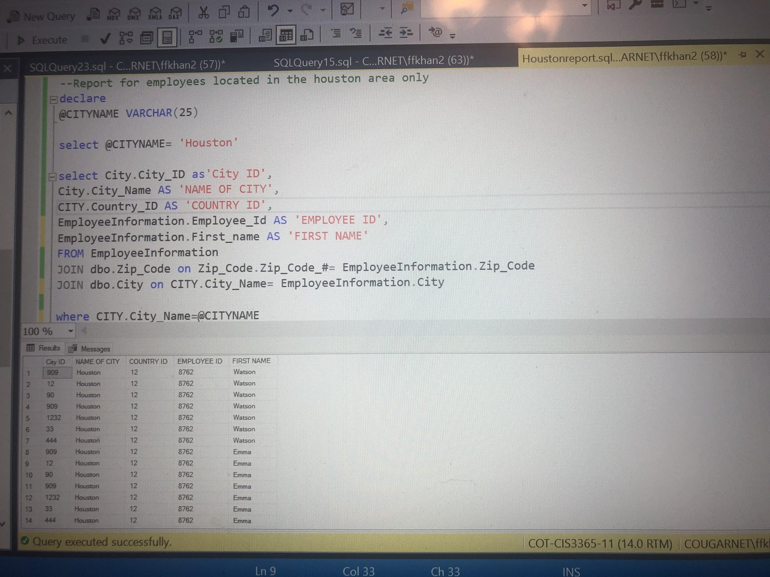

**Business Report 2**

**Report Name:** All Klaus Brewery Glassware that are of 2.8oz capacity.

**Report Description**: This report displays all glassware for Klaus which has a capacity of 2.8oz. These glasswares range from wine glasses to beer glasses.

**Business Purpose:** Purpose for these reports is that through use of these types of reports , Our client can keep track of all their glasses sized for capacity of no more than 2.8 capacity and this can be very helpful for inventory purposes as well.

**SQL CODE:**

--Reports for 2.8oz capacity glasses

declare

@SIZE varchar(60)

--select @SIZE= 1

select @SIZE= '2.8 oz capacity'

select Glassware.Glassware_ID as 'Glassware ID',

Glassware.GlasswareSize_ID AS 'Glass size ID',

Glassware.Glassware_Description AS 'Description',

Glassware.MerchandiseType_ID as 'Merchandise type ID',

GlasswareSize.Size as 'Description'

FROM Glassware

JOIN dbo.GlasswareSize on Glassware.Glassware_Description= GlasswareSize.Size

where GlasswareSize.Size= @SIZE

**Report/Query Results:**

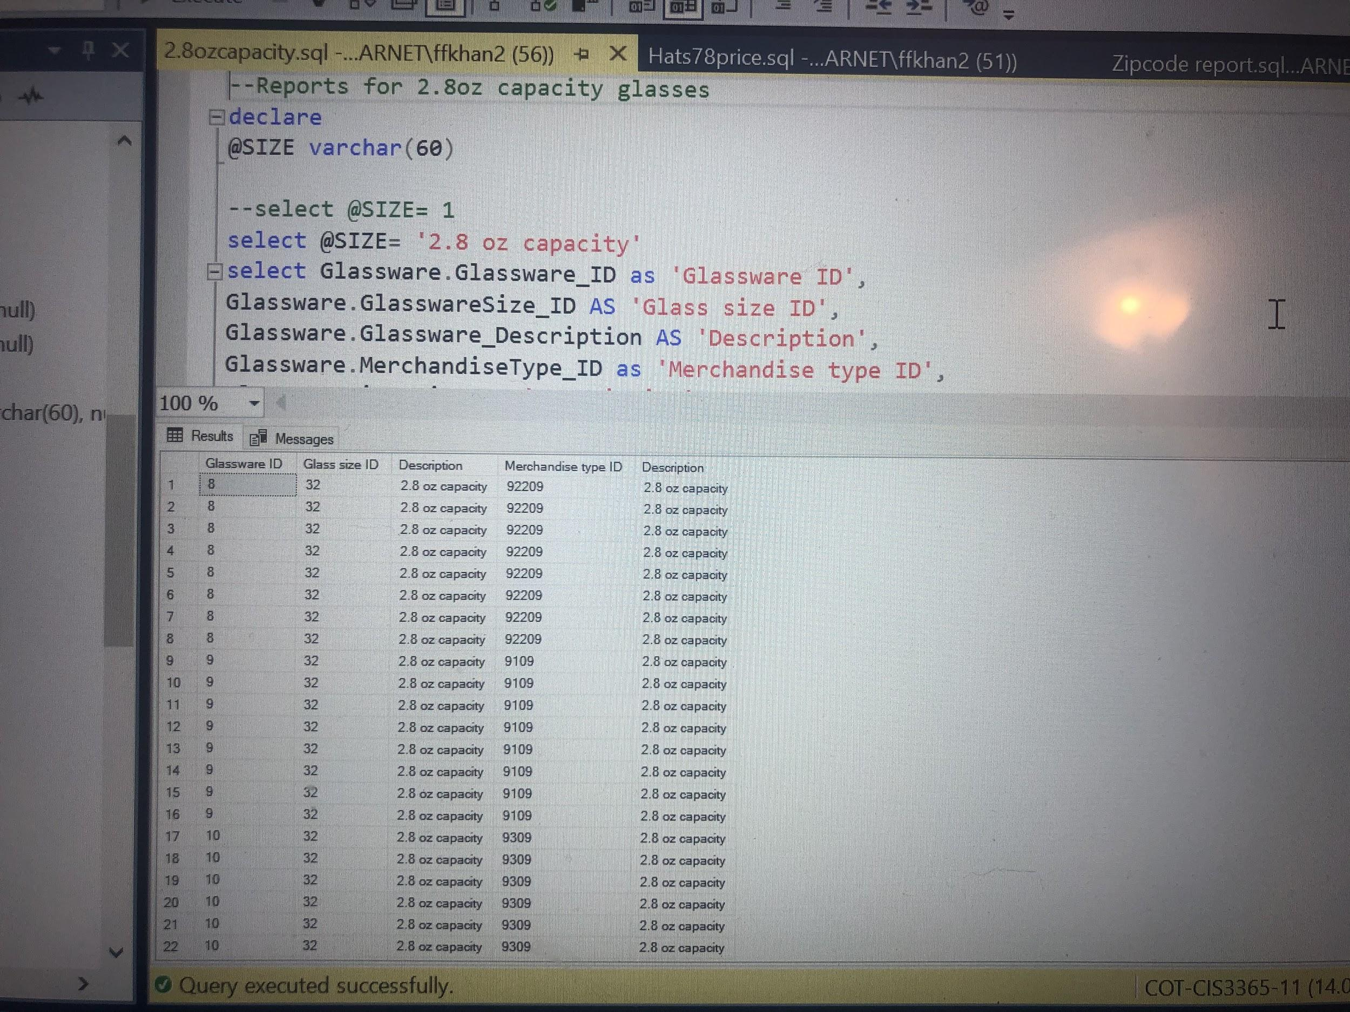

**Business Report 3**

**Report Name:** All Klaus Brewery Hats that are priced $78.

**Report Description**: This reports gives a good detailed information regarding all types and sizes of hats at Klaus Brewery that are on sale for $78.

**Business Purpose:** This type of reports will largely benefit our client in their products and sales management. This will assist them in analyzing and categorizing products individually based on their prices.

**SQL CODE:**

--Report for hats with price of $78

declare

@PRICE float

select @PRICE= $78

select Hats.Hat_ID as 'Hat ID',

Hats.Hat_price as 'Price',

Hats.Hat_ColorID as 'Color ID',

Products.Brewery_ID as 'Brewery ID'

FROM PRODUCTS

JOIN dbo.Hats on HATS.Hat_price= Products.Product_Price

where Hats.Hat_price=@PRICE

**Report/Query Results:**

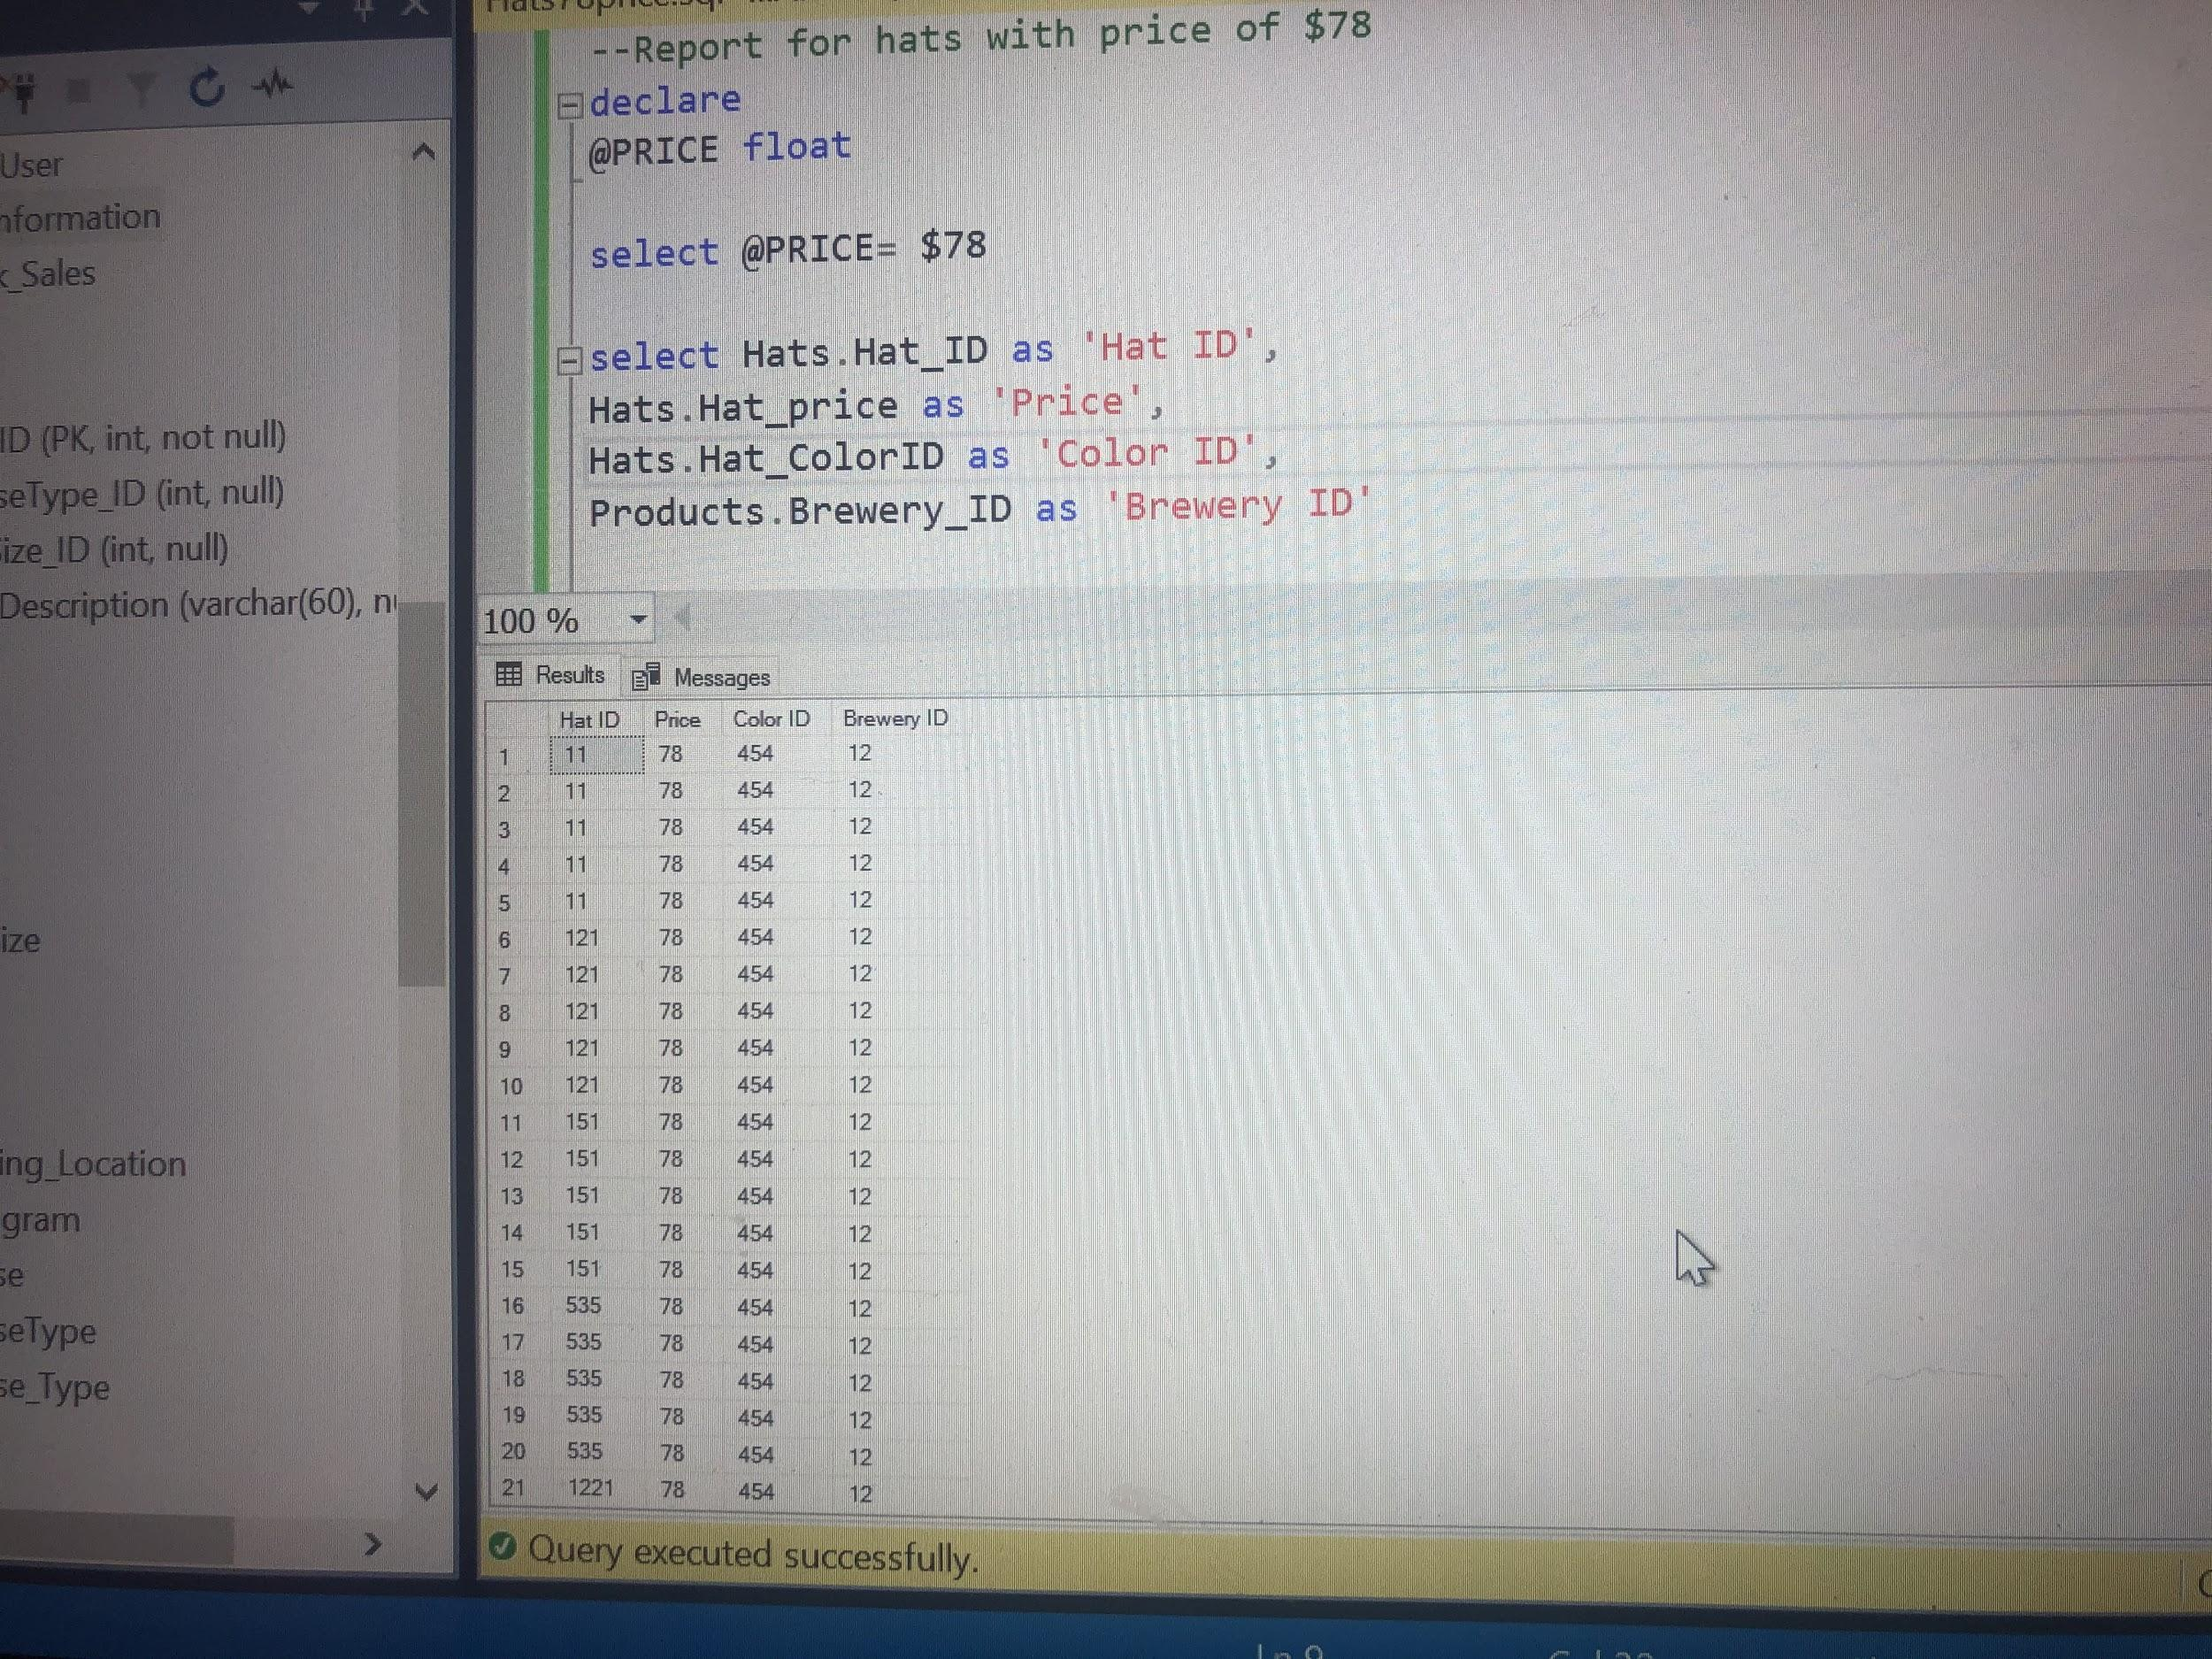

**Business Report 4**

**Report Name:** All Klaus Brewery employees located in the zip code 77871.

**Report Description**: This reports displays names , address and other valuable data regarding all employees of klaus that live in zip code 77871.

**Business Purpose:** This is a very beneficial report since it will help our client understand and better accommodate their employees in terms of their location. This will also be helpful in analyzing what employees can and cannot get to Brewery location in case of a flood or other natural disaster since this zip code is closer in proximity to brewery.

**SQL CODE:**

--Report for employees located in the zip code 77871 only

declare

@emptable INT

select @emptable= 77871

select EmployeeInformation.Zip_Code AS 'Zip code for employee',

Zip_Code.Zip_Code_# AS 'Zip Code',

EmployeeInformation.First_name as 'First name',

EmployeeInformation.Middle_Initial as 'Middle',

EmployeeInformation.Last_name as 'Last name',

EmployeeInformation.City AS 'CITY',

Employee_Address AS 'ADDRESS'

FROM EmployeeInformation

JOIN dbo.Zip_Code on Zip_Code.Zip_Code_#= EmployeeInformation.Zip_Code

where Zip_Code.Zip_Code_#=@emptable

**Report/Query Results:**

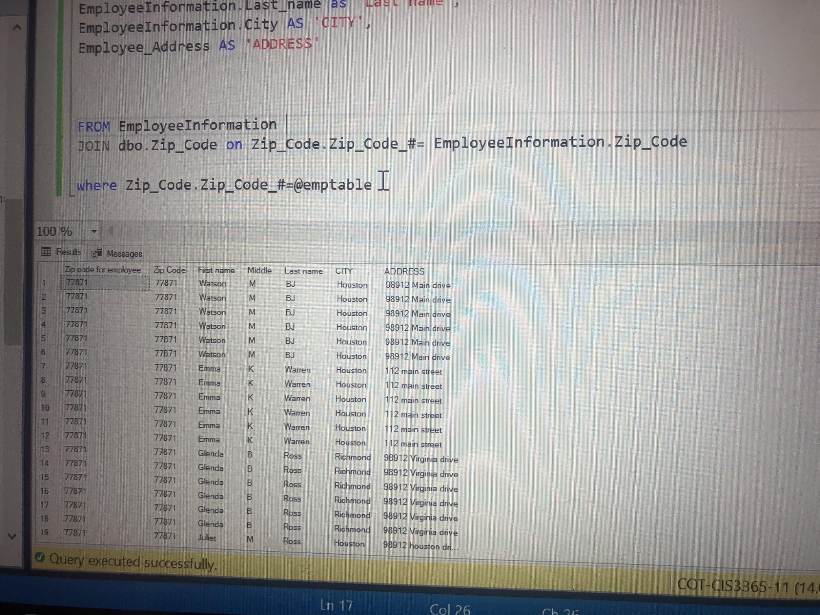

-----------------**Adekunle**-----------------

**Business Report 1**

**Report Name:** Beer products by container 3

**Report Description:** Selects Beer products are served with the ‘Glass” container.

**Business Purpose:** The client could use this report to see how many of the beer orders were served in glasses for the customers

**SQL CODE:**

--Report for to search for which Beers have a container called 'Glass'

declare

@check varchar(30)

select @check ='Glass'

SELECT

Beer.Product_ID as 'Product ID',

Beer.Beer_Name as 'BeerName',

BeerType.Beer_Type as 'BeerType',

Beer_Container_Size.Container_Name as 'Container',

Beer_Container_Size.Size as 'Size',

BeerList.ABV as 'ABV',

BeerList.IBU as 'IBU'

From Beer

Join BeerList on BeerList.Beer_Name = Beer.Beer_Name

Join BeerType on BeerType.BeerType_ID = Beer.BeerType_ID

Join Beer_Container_Size on Beer_Container_Size.BeerContainerSize_ID = Beer.BeerContainerSize_ID

Join Products on Products.Product_ID = Beer.Product_ID

where Beer_Container_Size.Container_Name = @check

**Report/Query Results**

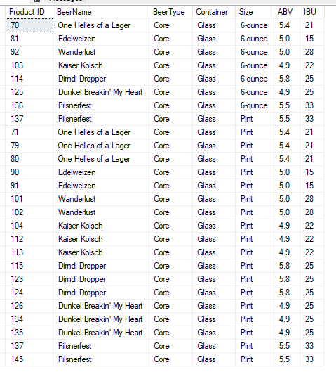

**Business Report 2**

**Report Name:** Beer Products by container 1

**Report Description:** Selects Beer products are served with the ‘Bottle” container.

**Business Purpose:** The client could use this report to see how many of the beer orders were served in to-go bottles for the customers

**SQL CODE:**

declare

@check varchar(30)

select @check ='Bottle'

SELECT

Beer.Product_ID as 'Product ID',

Beer.Beer_Name as 'BeerName',

BeerType.Beer_Type as 'BeerType',

Beer_Container_Size.Container_Name as 'Container',

Beer_Container_Size.Size as 'Size',

BeerList.ABV as 'ABV',

BeerList.IBU as 'IBU'

From Beer

Join BeerList on BeerList.Beer_Name = Beer.Beer_Name

Join BeerType on BeerType.BeerType_ID = Beer.BeerType_ID

Join Beer_Container_Size on Beer_Container_Size.BeerContainerSize_ID = Beer.BeerContainerSize_ID

Join Products on Products.Product_ID = Beer.Product_ID

where Beer_Container_Size.Container_Name = @check

**Report/Query Results**

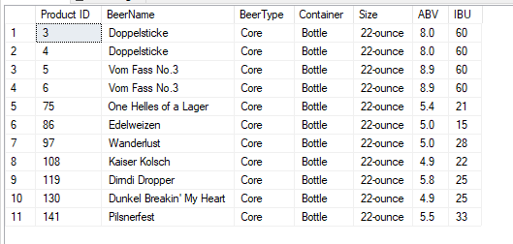

BeerList Table

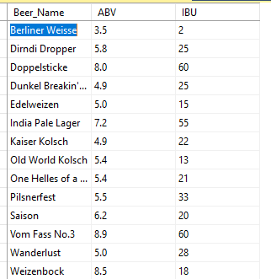

BeerType table

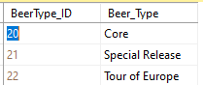

Beer_Container_Size table

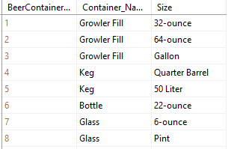

**Business Report 3**

**Report Name:** Beer Products by container 4

**Report Description:** Selects Beer products are served with the ‘Growler Fill” container.

**Business Purpose:** The client could use this report to see how many of the beer orders were served in Growler fill for the customers

**SQL CODE:**

declare

@check varchar(30)

select @check ='Growler Fill'

SELECT

Beer.Product_ID as 'Product ID',

Beer.Beer_Name as 'BeerName',

BeerType.Beer_Type as 'BeerType',

Beer_Container_Size.Container_Name as 'Container',

Beer_Container_Size.Size as 'Size',

BeerList.ABV as 'ABV',

BeerList.IBU as 'IBU'

From Beer

Join BeerList on BeerList.Beer_Name = Beer.Beer_Name

Join BeerType on BeerType.BeerType_ID = Beer.BeerType_ID

Join Beer_Container_Size on Beer_Container_Size.BeerContainerSize_ID = Beer.BeerContainerSize_ID

Join Products on Products.Product_ID = Beer.Product_ID

where Beer_Container_Size.Container_Name = @check

**Report/Query Results**

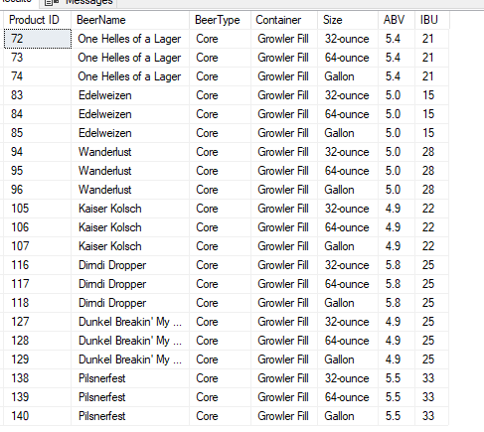

**Business Report 4**

**Report Name:** Beer Products by container 2

**Report Description:** Selects Beer products are served with the ‘Keg” container.

**Business Purpose:** The client could use this report to see how beer orders were served in kegs for the customers

**SQL CODE:**

declare

@check varchar(30)

select @check ='Keg'

SELECT

Beer.Product_ID as 'Product ID',

Beer.Beer_Name as 'BeerName',

BeerType.Beer_Type as 'BeerType',

Beer_Container_Size.Container_Name as 'Container',

Beer_Container_Size.Size as 'Size',

BeerList.ABV as 'ABV',

BeerList.IBU as 'IBU'

From Beer

Join BeerList on BeerList.Beer_Name = Beer.Beer_Name

Join BeerType on BeerType.BeerType_ID = Beer.BeerType_ID

Join Beer_Container_Size on Beer_Container_Size.BeerContainerSize_ID = Beer.BeerContainerSize_ID

Join Products on Products.Product_ID = Beer.Product_ID

where Beer_Container_Size.Container_Name = @check

**Report/Query Results**

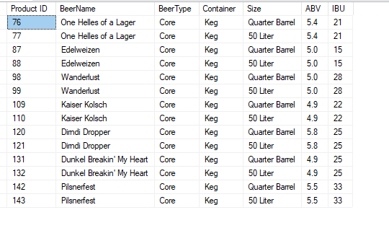

-----------------**Sean**-----------------

**Business Report 1**

**Report Name:** Customer by points value (redemption history)

**Report Description:** Selects customers that have redeemed points equal to 1098 in rewards

**Business Purpose:** The client could use this type of report to assist in giving out promotions. If Klaus Brewery wishes to reward their most loyal customers, they can reference this report.

**SQL CODE:**

declare

@PointsCost int

select @PointsCost= 1098

select

Redemption_History.CustomerProfile_ID as 'Reward for Customer ID',

Redemption_History.Points_Value as 'Points',

Rewards.Reward_Description as 'Description'

FROM Redemption_History

JOIN dbo.Rewards on Redemption_History.Points_Value= Redemption_Cost

where Redemption_History.Points_Value=@PointsCost

**Report/Query Results:**

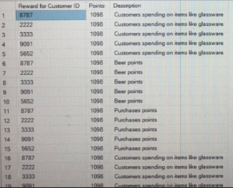

**Business Report 2**

**Report Name:** T-Shirts by Design

**Report Description:** Selects T-Shirts made for women that have floral designs

**Business Purpose:** The client could use this type of report to assist a customer in purchasing a t-shirt. Customers could also browse for a specific t-shirt design before making a decision to purchase one.

**SQL CODE:**

declare

@Design varchar(50)

select @Design= 'T-shirts with floral design for women'

select

TShirt_Type.Tshirt_TypeID as 'Type ID',

Products.Product_Price as 'Price for product',

TShirt_Type.Tshirt_Design AS 'Description'

FROM TShirt_Type

JOIN dbo.Products on Products.Product_Description= TShirt_Type.Tshirt_Design

where Products.Product_Description=@Design

**Report/Query Results:**

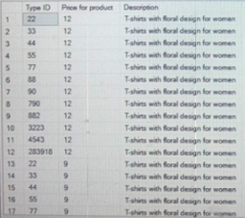

**Business Report 3**

**Report Name:** Customers by Loyalty Program Points

**Report Description:** Selects customers that are members and have 100 points

**Business Purpose:** The client could use this type of report to assist in setting new rewards for the loyalty program. If the client wishes to add a big ticket reward, they can make sure it will not be easy to redeem by first checking which customer already has 100 points.

**SQL CODE:**

declare

@Points INT

select @Points= 100

select Customer_Profile.CustomerProfile_ID as 'Customer Profile ID',

Customer_Profile.Total_Available_Points as 'Points',

Customer_Profile.Average_Amount as 'Amount',

Customer_Profile.Amount_Spent as 'Amount spent',

Customer_Profile.Last_Visit as 'Last visit'

FROM Redemption_History

JOIN dbo.Customer_Profile on Total_Available_Points= Redemption_History.Points_Value

where Total_Available_Points= @Points

**Report/Query Results:**

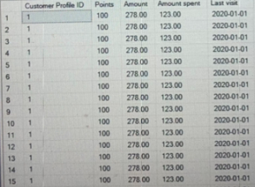

**Business Report 4**

**Report Name:** Employees by state of residency

**Report Description:** Selects Klaus Brewery employees that reside in the state of Texas.

**Business Purpose:** The client could use this type of report to assist in managerial decisions. If there is a new location opening up in Texas, they could reference this report and ask an employee if they’d like to transfer and become manager in order to train new staff members at said location.

**SQL CODE:**

declare

@Stateofresi varchar(20)

select @Stateofresi= 'TX'

select EmployeeInformation.First_name as 'First Name',

EmployeeInformation.Last_name as 'Last name',

EmployeeInformation.Country_ID as 'Id of country',

State.State_ID AS 'State Id',

State.State_Name as 'Name of state'

FROM EmployeeInformation

JOIN dbo.State on State_Name= EmployeeInformation.State

where State_Name= @Stateofresi

**Report/Query Results:**

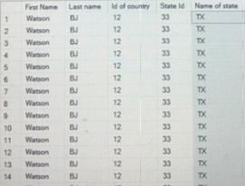

-----------------**Pratik**-----------------

**Business Report 1**

**Report Name:** Reports for Inventory for all flat caps for kids in stock for several colors

**Report Description**: This reports displays all flats caps that klaus has in stock in several color variations as well.

**Business Purpose:** This report will help our client in keeping track of all their flat cap hats in their inventories systems and stock.

**SQL CODE:**

-- Reports for Inventory for all flat caps for kids in stock for several colors

declare @Hat1 varchar(60)

select @Hat1= 'Flat cap for kids'

select

Hat_Color.Color as 'Color',

Hat_Color.Hat_Description as 'Description',

Products.Product_Price as 'Price'

FROM Hat_Color

JOIN dbo.Products on Product_Description= Hat_Color.Hat_Description

where Product_Description= @Hat1

**Report/Query Results**

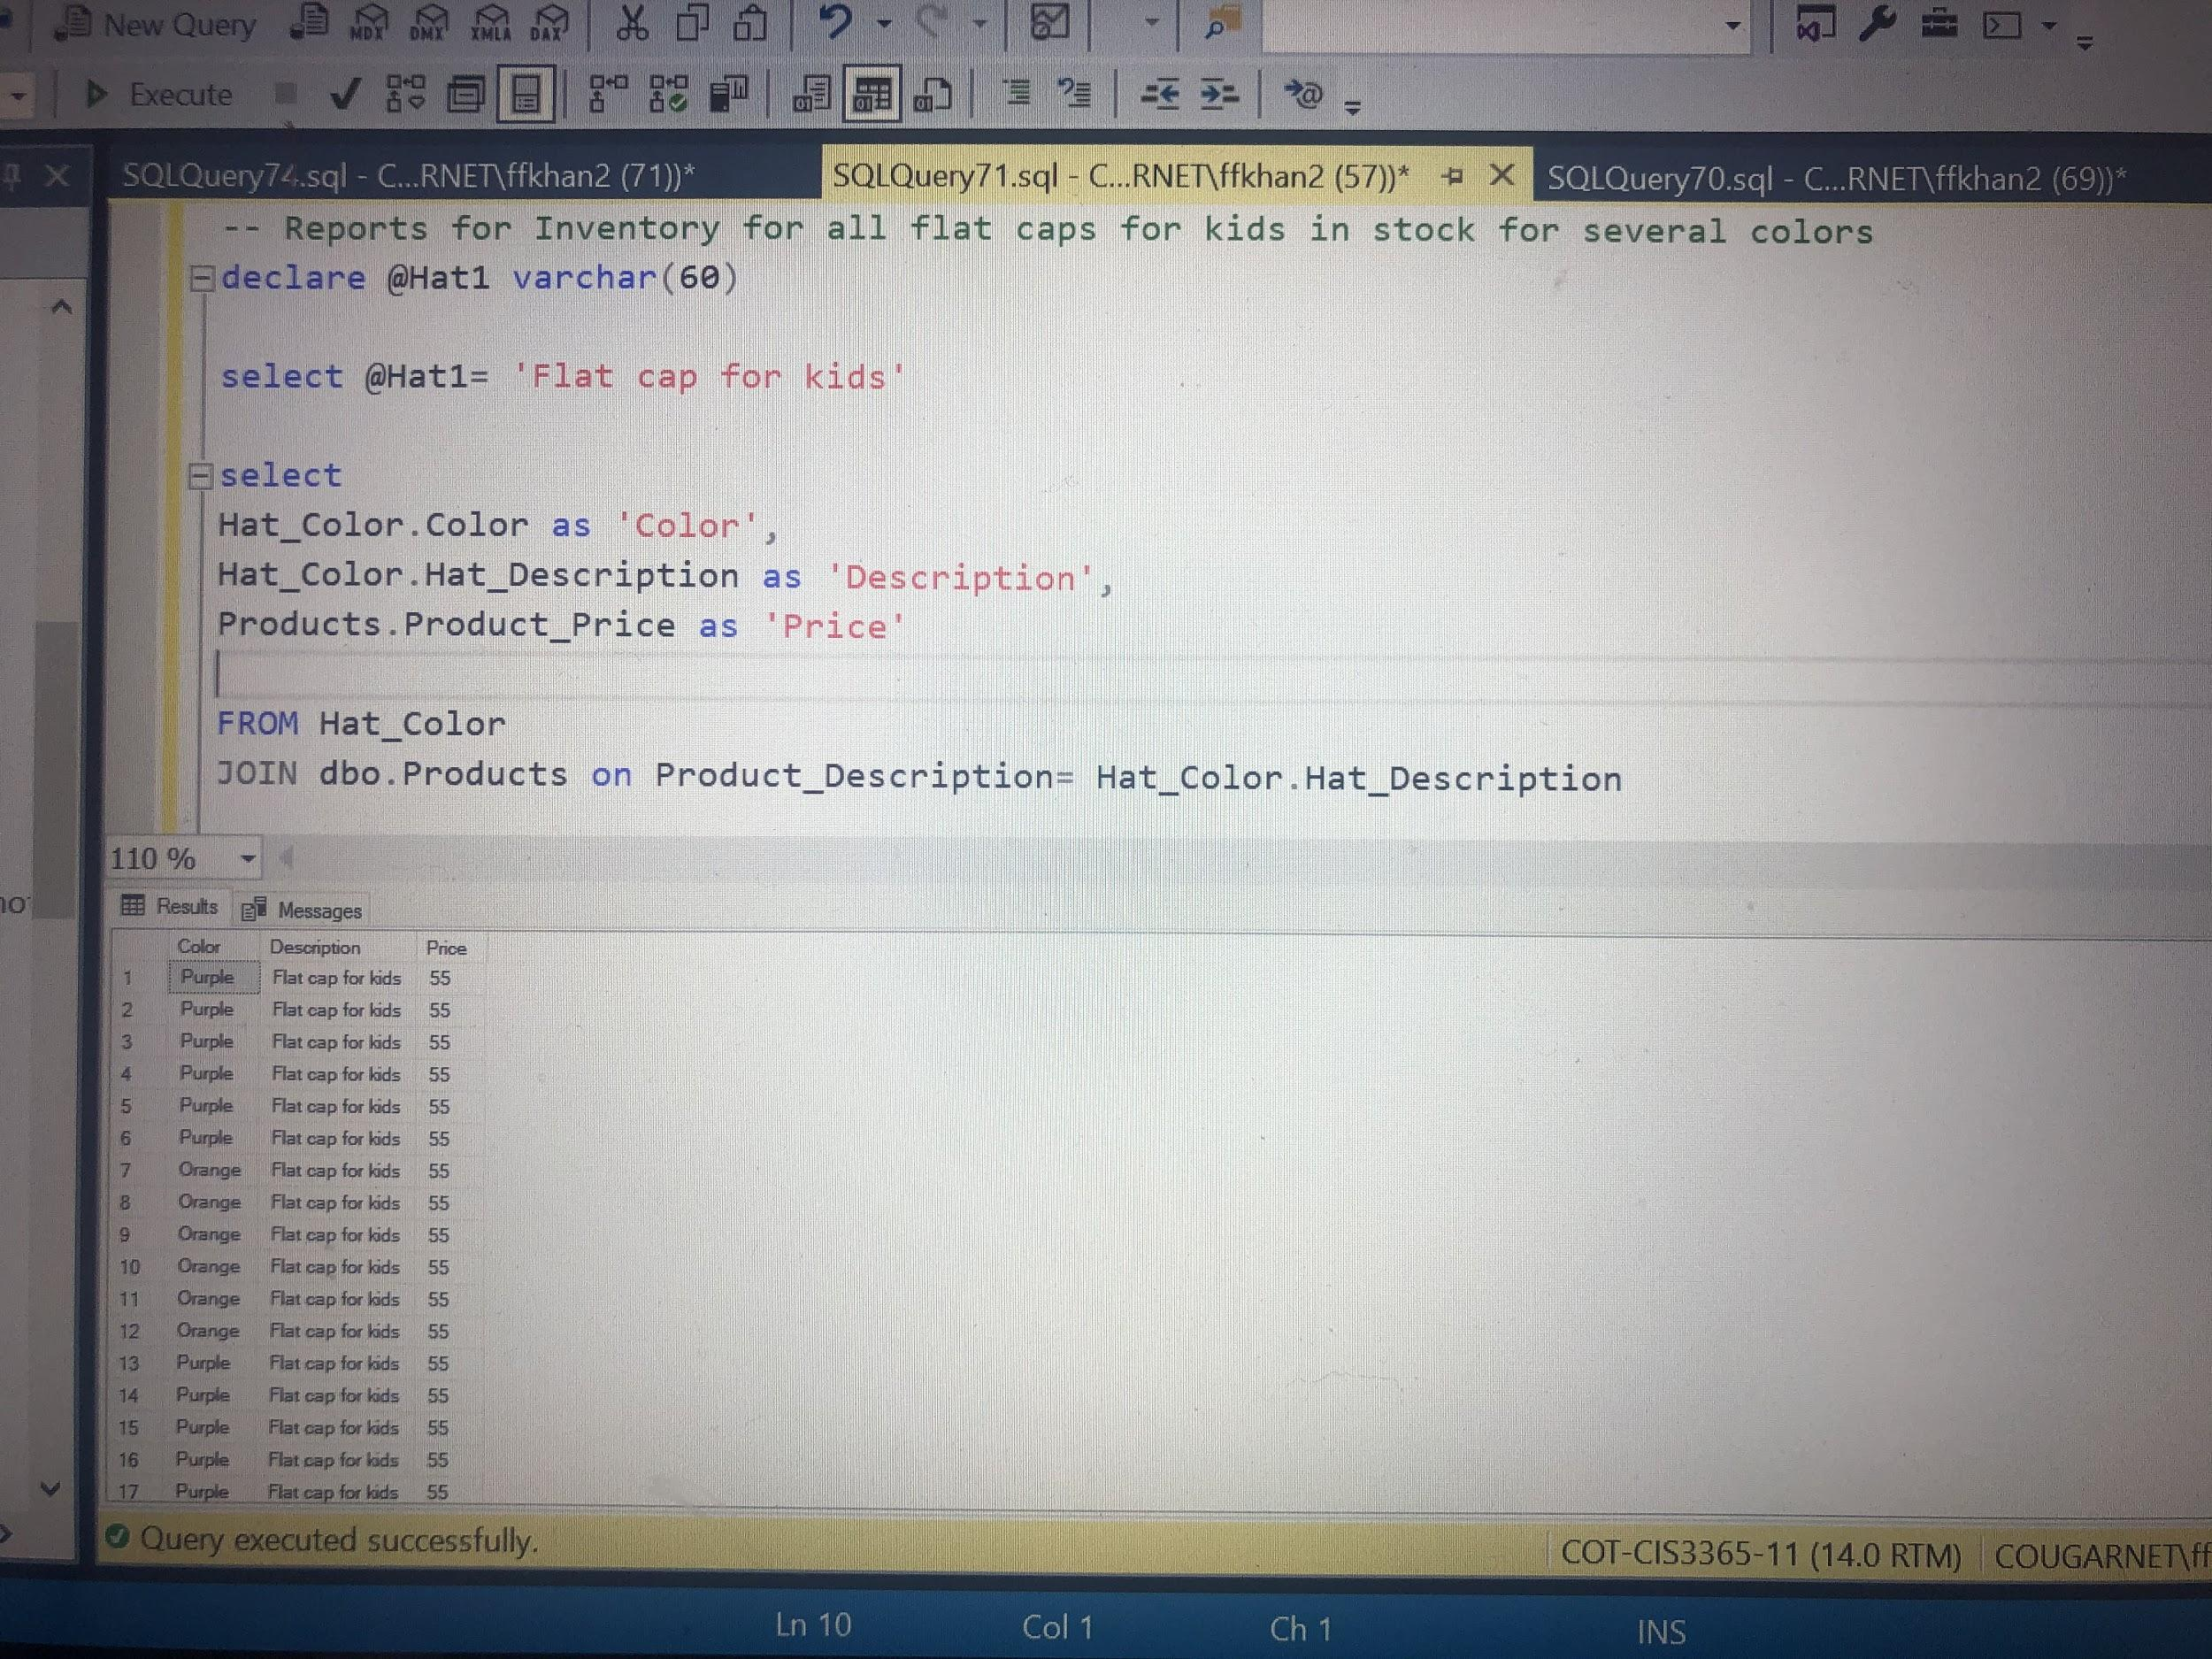

**Business Report 2**

**Report Name:** Reports for Inventory for all Baseball caps for kids in stock for several colors

**Report Description**: This reports displays all Baseball caps that klaus has in stock in several color variations as well.

**Business Purpose:** This report will help our client in keeping track of all their Baseball cap hats in their inventories systems and stock in order to have all their items aligned as well.

**SQL CODE:**

-- Reports for Inventory for all Baseball caps for kids in stock for several colors

declare @Hat2 varchar(60)

select @Hat2= 'Baseball cap for men'

select

Hat_Color.Color as 'Color',

Hat_Color.Hat_Description as 'Description',

Products.Product_Price as 'Price'

FROM Hat_Color

JOIN dbo.Products on Product_Description= Hat_Color.Hat_Description

where Product_Description= @Hat2

**Report/Query Results**

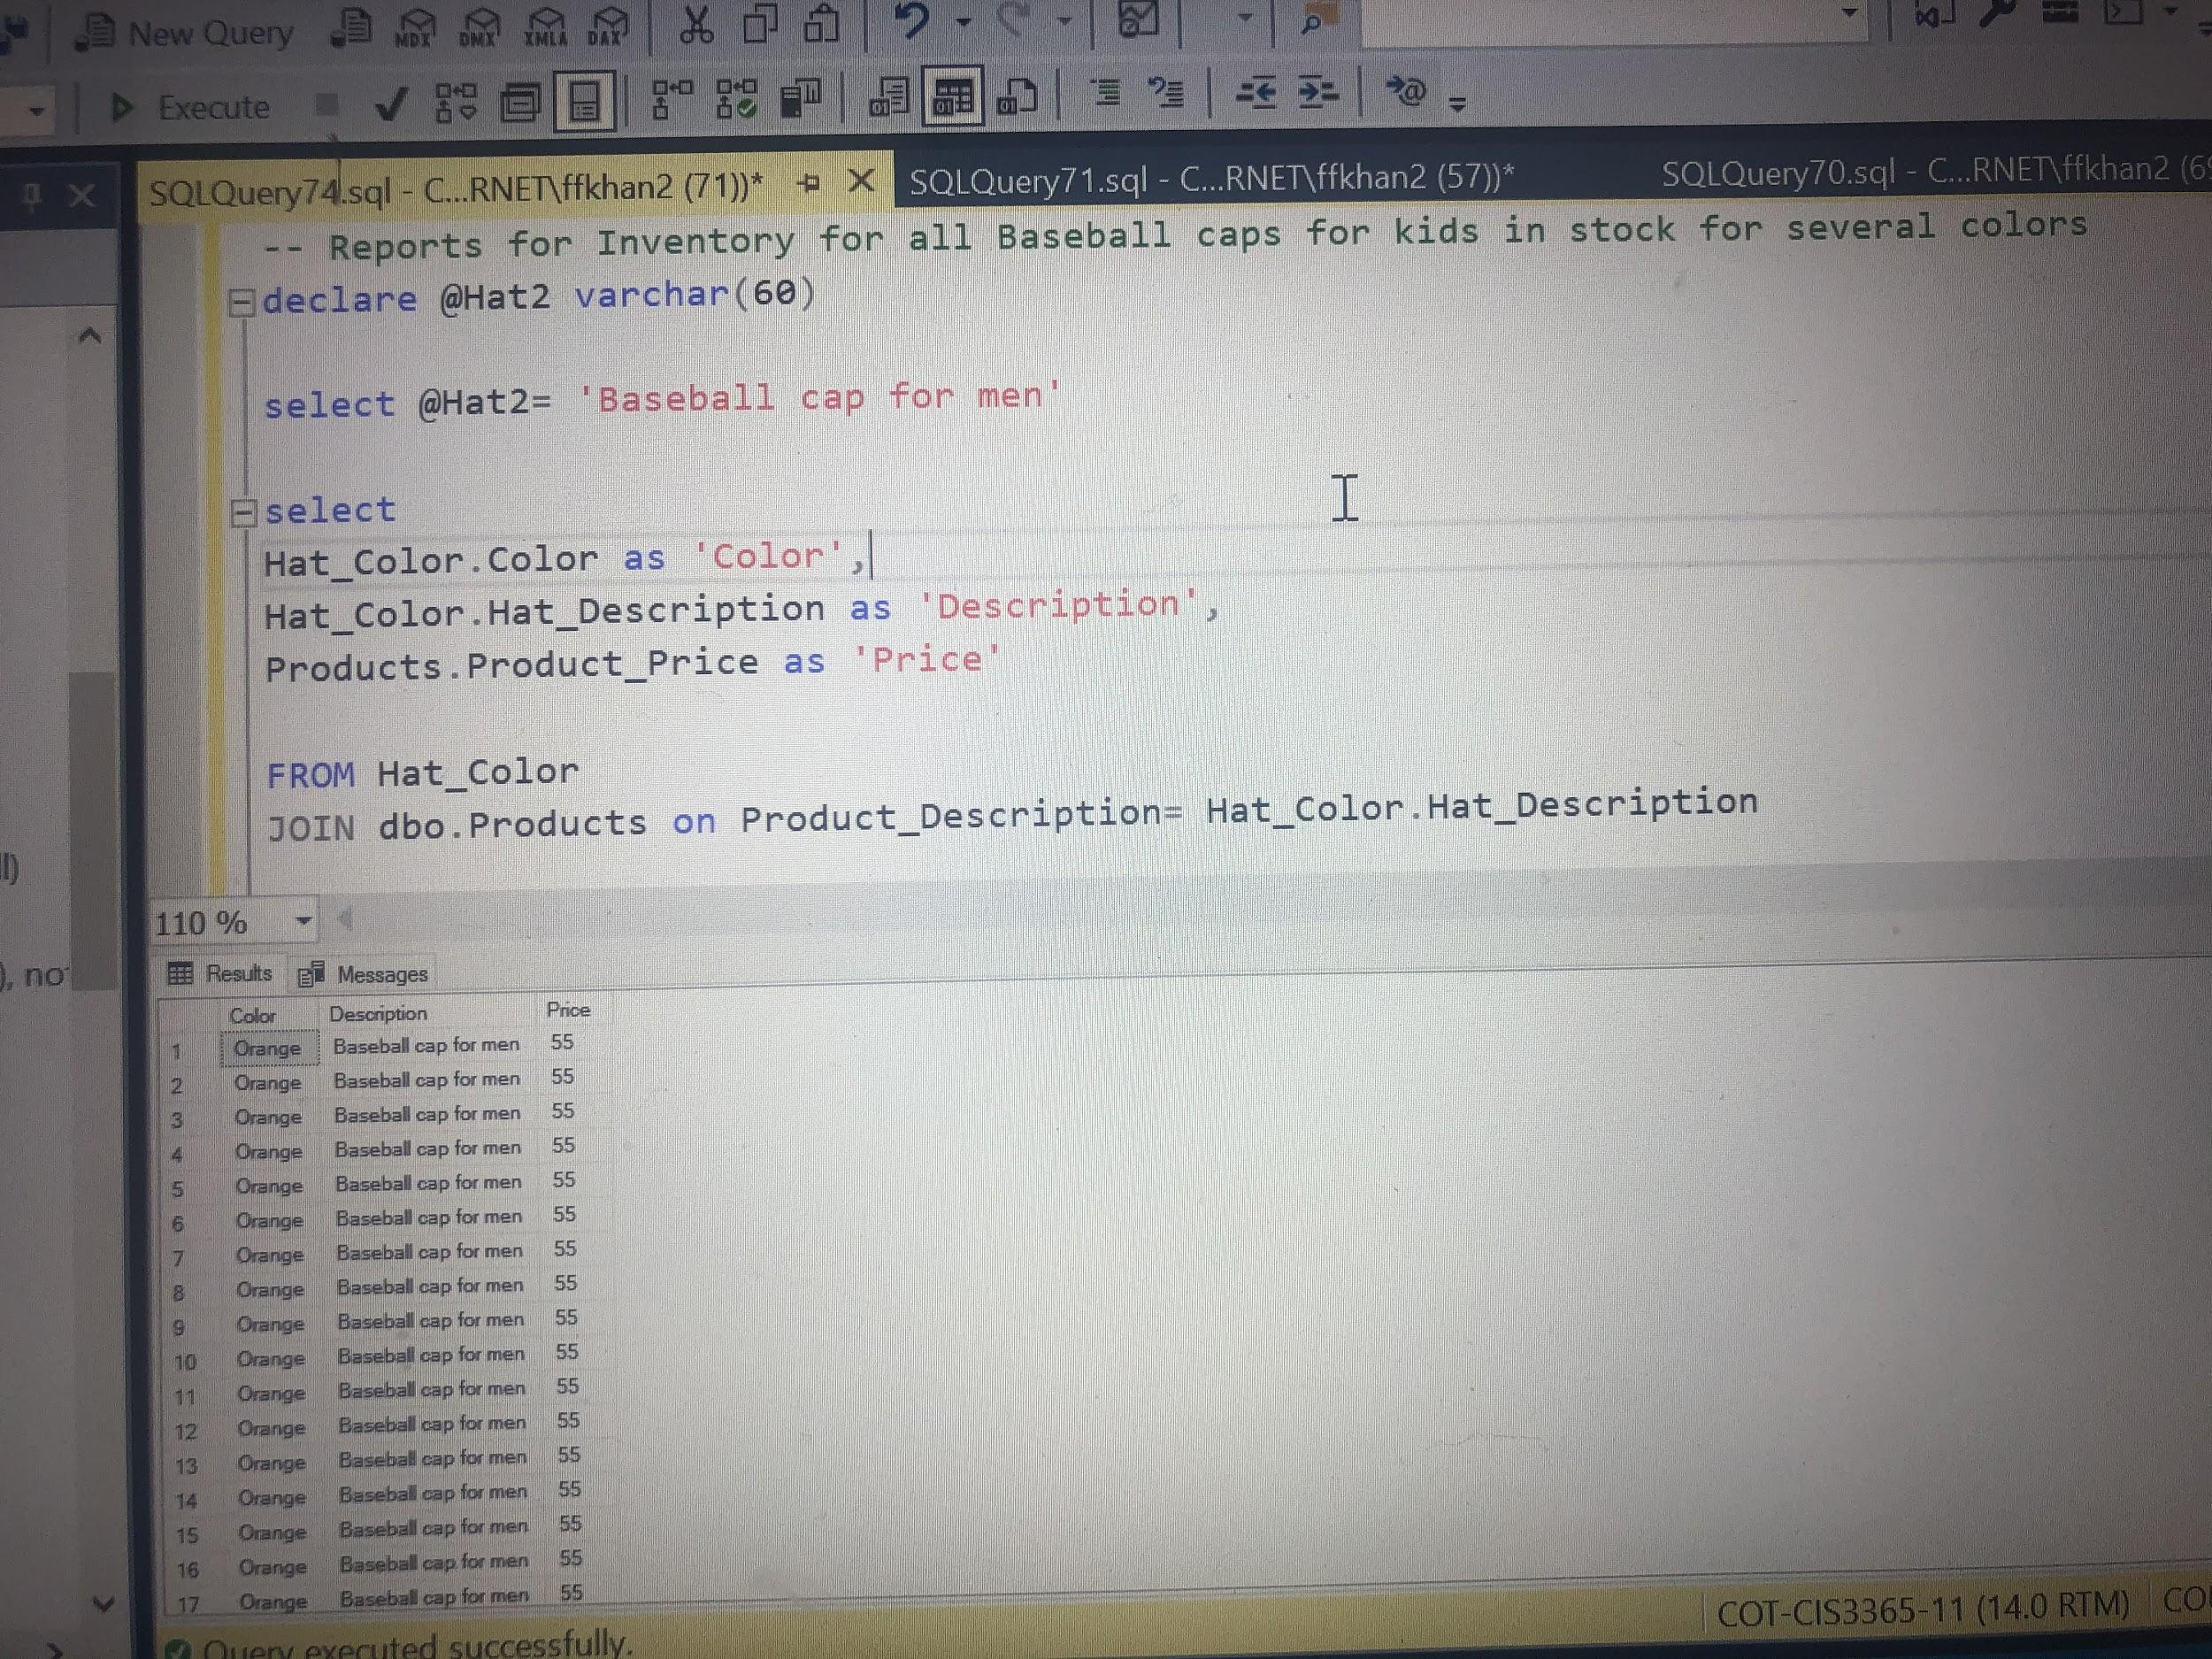

**Business Report 3**

**Report Name:** Reports for Inventory for all Boater caps for women in stock for several colors

**Report Description**: This will be very helpful in keeping track of all their Boater hats.

**Business Purpose:** This report will help our client in keeping track of all their Boater cap hats in their inventories systems and stock in order to have all their items aligned as well.

**SQL CODE:**

-- Reports for Inventory for all Boater caps for women in stock for several colors

declare @Hat3 varchar(60)

select @Hat3=’ Boater cap for women’

select

Hat_Color.Color as 'Color',

Hat_Color.Hat_Description as 'Description',

Products.Product_Price as 'Price'

FROM Hat_Color

JOIN dbo.Products on Product_Description= Hat_Color.Hat_Description

where Product_Description= @Hat3

**Business Report 4**

**Report Name:** Reports for Inventory for all Beanie caps for kids in stock for several colors

**Report Description**: This will be very helpful in keeping track of all their Beanie hats.

**Business Purpose:** This report will help our client in keeping track of all their Beanie cap hats in their inventories systems and stock in order to have all their items aligned as well.

**SQL CODE**

-- Reports for Inventory for all Beanie caps for women in stock for several colors

declare @Hat4 varchar(60)

select @Hat4= ‘Beanie cap for women’

select

Hat_Color.Color as 'Color',

Hat_Color.Hat_Description as 'Description',

Products.Product_Price as 'Price'

FROM Hat_Color

JOIN dbo.Products on Product_Description= Hat_Color.Hat_Description

where Product_Description= @Hat4

------Chantera------

**Business Report 1**

**Report Name:** Redemption History

**Report Description:** Lists a customer’s redemption history

**Business Purpose:** The client would like to see the redemption history of a particular customer too see what they favor. They might also want to see which reward is a favorite among customers. Lastly, it is also for customers to track their redemption history.

**SQL CODE:**

Use [Klaus Loyalty Program]

DECLARE

@CustOfInt INT

SELECT @CustOfInt ='2'

SELECT [Customer Info].Customer_First,

[Customer Info].Customer_Last,

[Rewards].Reward_Description,

[Rewards].Redemption_Cost

FROM [Customer Info]

JOIN [Customer_User] ON [Customer_User].Customer_ID = [Customer Info].Customer_ID

JOIN [Customer_Profile] ON [Customer_Profile].CustomerProfile_ID = Customer_User.CustomerProfile_ID

JOIN [Redemption_History] ON [Redemption_History].CustomerProfile_ID = Customer_Profile.CustomerProfile_ID

JOIN [Rewards] ON Rewards.Reward_ID = Redemption_History.Reward_ID

WHERE Customer_Profile.CustomerProfile_ID = @CustOfInt

**Report/Query Results:**

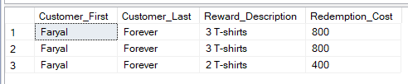

**Tables Referenced:**

**Customer Information**

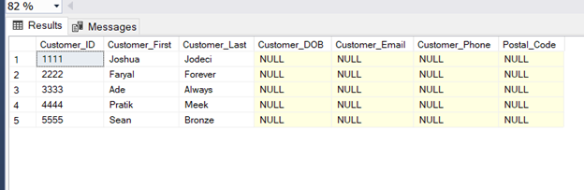

**Customer User**

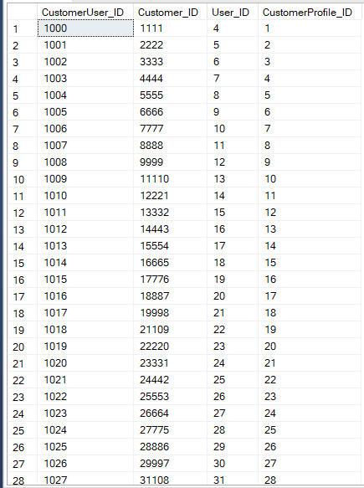

**Customer Profile**



**Redemption History**

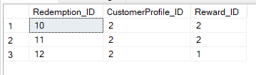

**Rewards**

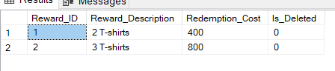

**Business Report 2**

**Report Name:** Database Administrations

**Report Description:** Lists the name of the Employee Administrations

**Business Purpose:** The client requests to see the name of the employees who have admin rights to make changes in the database.

**SQL CODE:**

DECLARE

@roleofint int

SELECT @roleofint = 1

SELECT [EmployeeInformation].First_name,

[EmployeeInformation].Last_name,

[Employee].Employee_Title

FROM [EmployeeInformation]

JOIN [Employee] ON [EmployeeInformation].Employee_ID = [Employee].Employee_ID

JOIN [Employee_User] ON [Employee_User].Employee_ID = [Employee].Employee_ID

JOIN [User] ON [User].User_ID = [Employee_User].User_ID

JOIN [Role] ON [Role].Role_ID = [User].Role_ID

WHERE [Role].Role_ID = @roleofint

**Report/Query Results:**

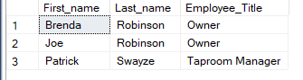

**Tables Referenced:**

**Employee Information**

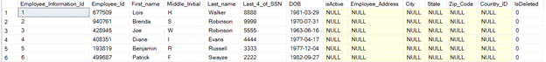

**Employee**

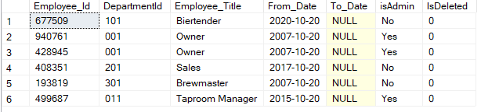

**Employee User**

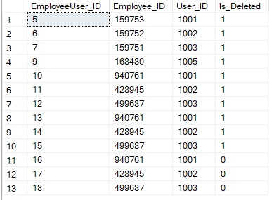

**Role**

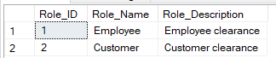

**Business Report 3**

**Report Name:** Gift Sets

**Report Description:** Lists the Gift Sets

**Business Purpose:** The client specifically requested the ability to pull up specific products to analyze what is still active and prices.

**SQL CODE:**

DECLARE

@ItemofInt int

SELECT @ItemofInt = '1'

SELECT [Products].Product_Description,

[Products].Product_Price,

[Products].Is_Deleted

FROM [Products]

JOIN [Misc_Item] ON [Misc_Item].Product_ID = [Products].Product_ID

JOIN [Item_Type] ON [Item_Type].ItemType_ID = [Misc_Item].ItemType_ID

WHERE [Item_Type].ItemType_ID = @ItemofInt

**Report/Query Results:**

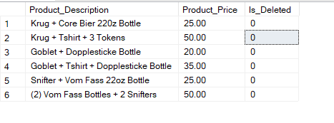

**Tables Referenced:**

**Partial Products (1-17 out of 294 items)**

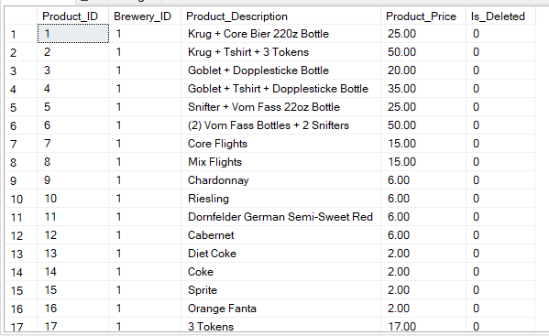

**Misc Items**

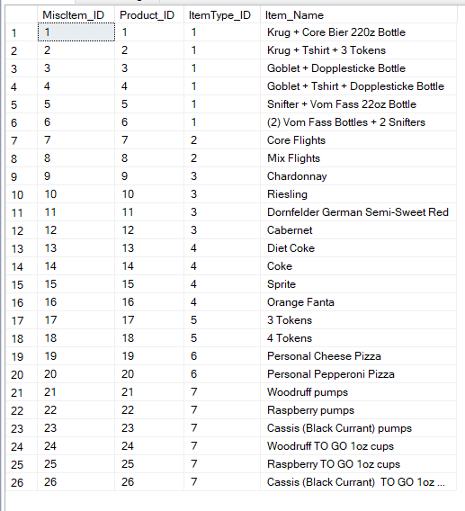

**Item Type**

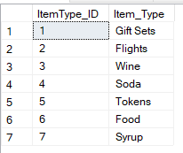

**Business Report 4**

**Report Name:** Order Details

**Report Description:** Selects order details for a specific order

**Business Purpose:** The client requests to see order details in order to investigate the order as well as for future purposes such as a discrepancy concern with the customer. They can just pull up the order and verify any information needed

**SQL CODE:**

Use [Klaus Loyalty Program]

DECLARE

@brewofInt int,

@OrderofInt int

SELECT @OrderofInt = '1234'

SELECT [Order].Order_ID,

[Products].Product_Description,

[Products].Product_Price

FROM [Order]

JOIN [Order Details] ON [Order].Order_ID = [Order Details].Order_ID

JOIN [Products] ON [Products].Product_ID = [Order Details].Product_ID

WHERE [Order].Order_ID = @OrderofInt

**Report/Query Results:**

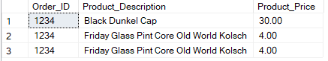

**Tables Referenced:**

**Order Table**

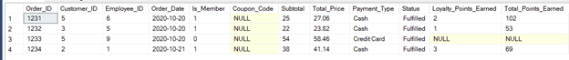

**Order Details**

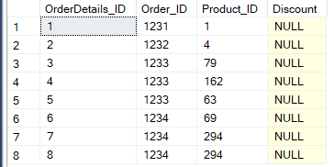

**Partial Product Table (1-17 items of 294)**



**------John------**

**Business Report 1**

**Report Name**: Brown Ale in Beer Selection

**Report Description:** Select brown ale type beers that are lambic that available in the beer list.

**Business Purpose:** The client could use this type of report to assist in outlook of product and innovation within the different types/styles of beers. Customers can also see what type of beers are available on hand

**SQL Code:**

declare

@Brownale varchar(60)

select @Brownale= 'Brown Ale'

select BeerType.Beer_Type as 'Type of beer',

Products.Product_Price as 'Price',

Products.Brewery_ID as 'Brewery Id'

FROM BeerType

JOIN dbo.Products on Product_Description= BeerType.Beer_Type

where Product_Description= @Brownale

**Business Report 2**

**Report Name**: Lambic in Beer Selection

**Report Description:** Select Lambic type beers that are lambic that available in the beer list.

**Business Purpose:** The client could use this type of report to assist in outlook of product and innovation within the different types/styles of beers. Customers can also see what type of beers are available on hand

**SQL CODE:**

declare

@Lambic varchar(60)

select @Lambic= 'Lambic'

select BeerType.Beer_Type as 'Type of beer',

Products.Product_Price as 'Price',

Products.Brewery_ID as 'Brewery Id'

FROM BeerType

JOIN dbo.Products on Product_Description= BeerType.Beer_Type

where Product_Description= @Lambic

**Report/Query Results**

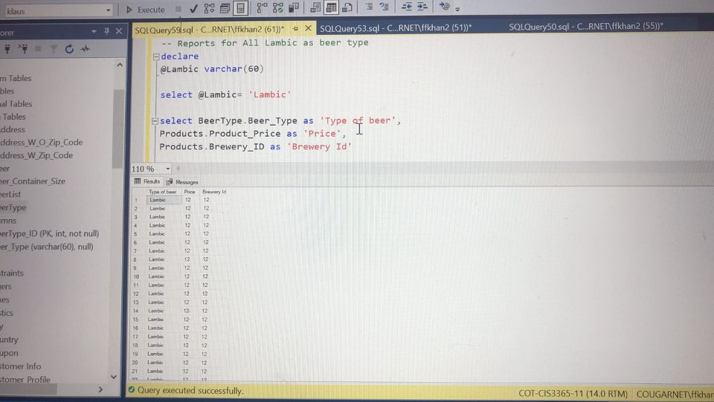

**Business Report 3**

**Report Name:** Type of Stout Beer in the Beerlist

**Report Description:**  Selects Stout style beer products that are within the inventory.

**Report Purpose:** The client could use this type of report to assist in outlook of product and innovation within the different types/styles of beers. Customers can also see what type of beers are available on hand.

**SQL Code**:

declare

@Typeofbeer varchar(60)

select @Typeofbeer= 'Stout'

select BeerType.Beer_Type as 'Type of beer',

Products.Product_Price as 'Price',

Products.Brewery_ID as 'Brewery Id'

FROM BeerType

JOIN dbo.Products on Product_Description= BeerType.Beer_Type

where Product_Description= @Typeofbeer

**Report/Query Results**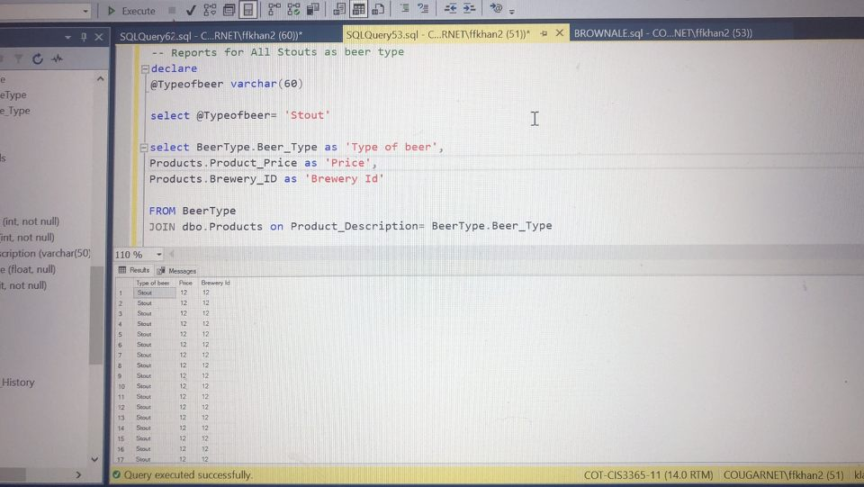

**Business Report 4**

**Report Name:** Dunkel Beer Products in House

**Report Description:** Selects Dunkel Style beer that is in the store and available for use.

**Report Purpose:** The client can see how many products that are in the inventory that are dunkel styled. This will allow them to identify what type of products they can get rid of or add. Clients can see of this style of beer is available on hand.

**SQL Code:**

declare

@Dunkel varchar(60)

select @Dunkel= 'Dunkel'

select BeerType.Beer_Type as 'Type of beer',

Products.Product_Price as 'Price',

Products.Brewery_ID as 'Brewery Id'

FROM BeerType

JOIN dbo.Products on Product_Description= BeerType.Beer_Type

where Product_Description= @Dunkel

**Report/Query Results**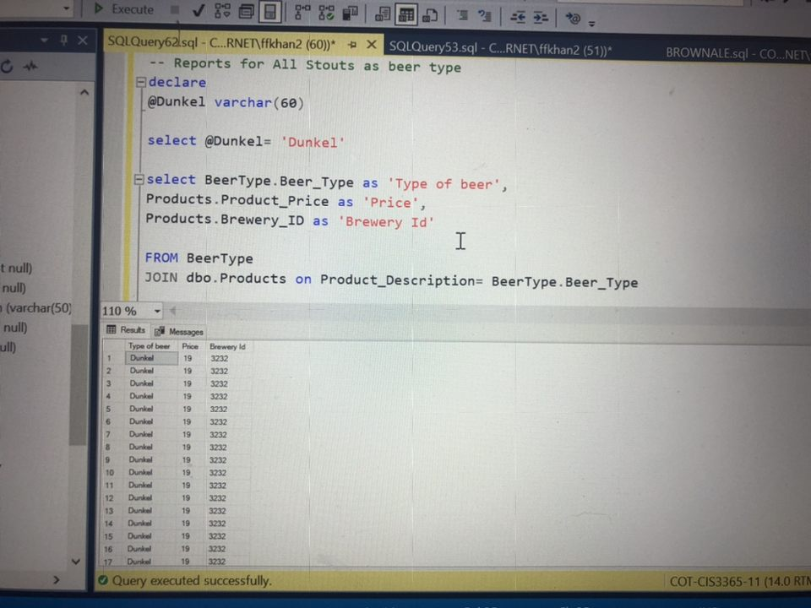

------Sem------

**Business Report 1**

**Report Name:** Shot glass

**Report Description:** Selects the glassware of short glasses

**Business Purpose:** The client could use this report to see how many shot glasses are sold. This can help to define which shot glasses are the most popular and which are not. This can greatly aid in keeping track of which particular glass should they keep in stock and the amount.

**SQL CODE:**

-- Reports for All Glassware categorized as Shot glasses

declare @Glassware2 varchar(60)

select @Glassware2= 'Shot glass'

select Glassware.Glassware_Description as 'Type of glassware',

Glassware.GlasswareSize_ID as 'Size ID',

Products.Product_Price as 'Price',

Products.Brewery_ID as 'Brewery Id'

FROM Glassware

JOIN dbo.Products on Product_Description= Glassware_Description

where Product_Description= @Glassware2

**Report/Query Results**

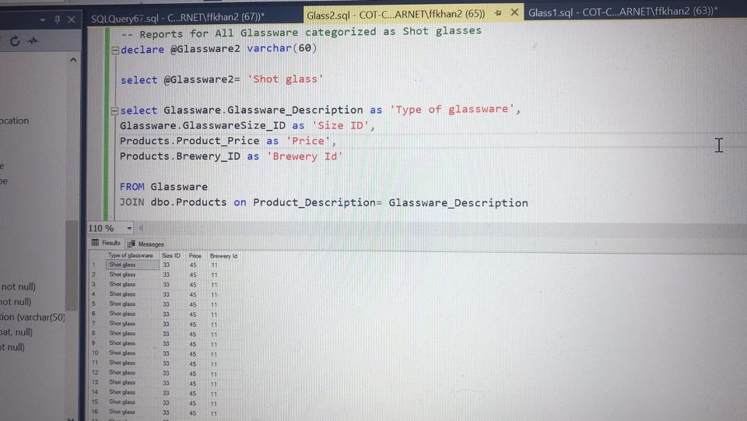

**Business Report 2**

**Report Name:** Cocktail glass

**Report Description:** Selects glassware of Cocktail glasses

**Business Purpose:** The client could use this report to see what particular cocktail glass is in demand. Certain cocktail glasses are sold more often than others. By tracking these orders they can improve their inventory

**SQL Code:**

-- Reports for All Glassware categorized as cockail glasses

declare @Glassware1 varchar(60)

select @Glassware1= 'Cocktail glass'

select Glassware.Glassware_Description as 'Type of glassware',

Glassware.GlasswareSize_ID as 'Size ID',

Products.Product_Price as 'Price',

Products.Brewery_ID as 'Brewery Id'

FROM Glassware

JOIN dbo.Products on Product_Description= Glassware_Description

where Product_Description= @Glassware1

-- Reports for All Glassware categorized as Shot glasses

declare @Glassware2 varchar(60)

**Report/Query Results**

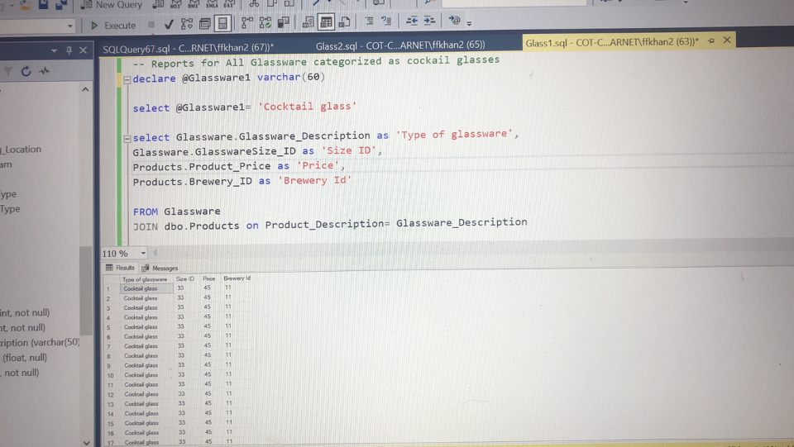

**Business Report 3**

**Report Name:** Pilsner glass

**Report Description:** Selects the glassware of short glasses

**Business Purpose:** The client could use this report to see how many Pilsner glasses are sold. This can help to define which Pilsner glasses are the most popular and which are not. This can greatly aid in keeping track of which particular glass should they keep in stock and the amount.

**SQL Code:**

-- Reports for All Glassware categorized as Pilsner

declare @Glassware3 varchar(60)

select @Glassware3= 'Pilsner'

select Glassware.Glassware_Description as 'Type of glassware',

Glassware.GlasswareSize_ID as 'Size ID',

Products.Product_Price as 'Price',

Products.Brewery_ID as 'Brewery Id'

FROM Glassware

JOIN dbo.Products on Product_Description= Glassware_Description

where Product_Description= @Glassware3

**Report/Query Results**

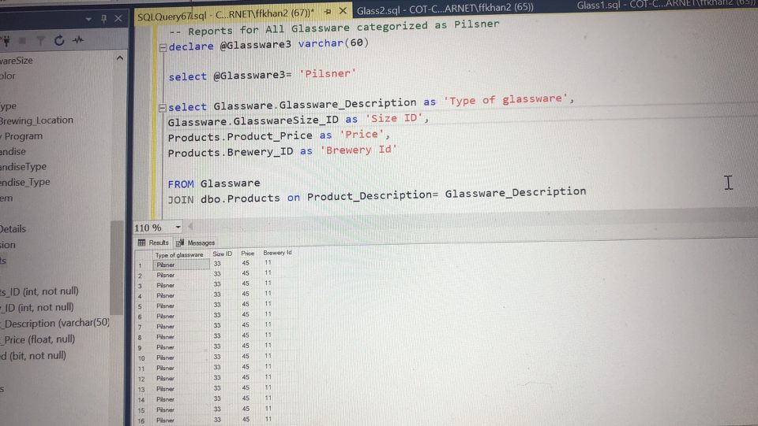

**Business Report 4**

**Report Name:** Pint glass

**Report Description:** Selects the glassware of Pint glasses

**Business Purpose:** The client could use this report to see how many Pint glasses are sold. These are the most common glassware that are used.This can help to define which Pint glasses are the most popular and which are not. This can greatly aid in keeping track of which particular glass should they keep in stock and the amount.

**SQL CODE:**

-- Reports for All Glassware categorized as Pint glass

declare @Glassware4 varchar(60)

select @Glassware4= 'Pint glass'

select Glassware.Glassware_Description as 'Type of glassware',

Glassware.GlasswareSize_ID as 'Size ID',

Products.Product_Price as 'Price',

Products.Brewery_ID as 'Brewery Id'

FROM Glassware

JOIN dbo.Products on Product_Description= Glassware_Description

where Product_Description= @Glassware4

